**Event Espresso Documentation contents**

Event Espresso

* Events
* Registrations
* Transactions

Management

* Messages
* Registration Form
* Venues

Settings

* General Settings
* Payment Methods

Frontend

**Ev****ents**

Add New Event

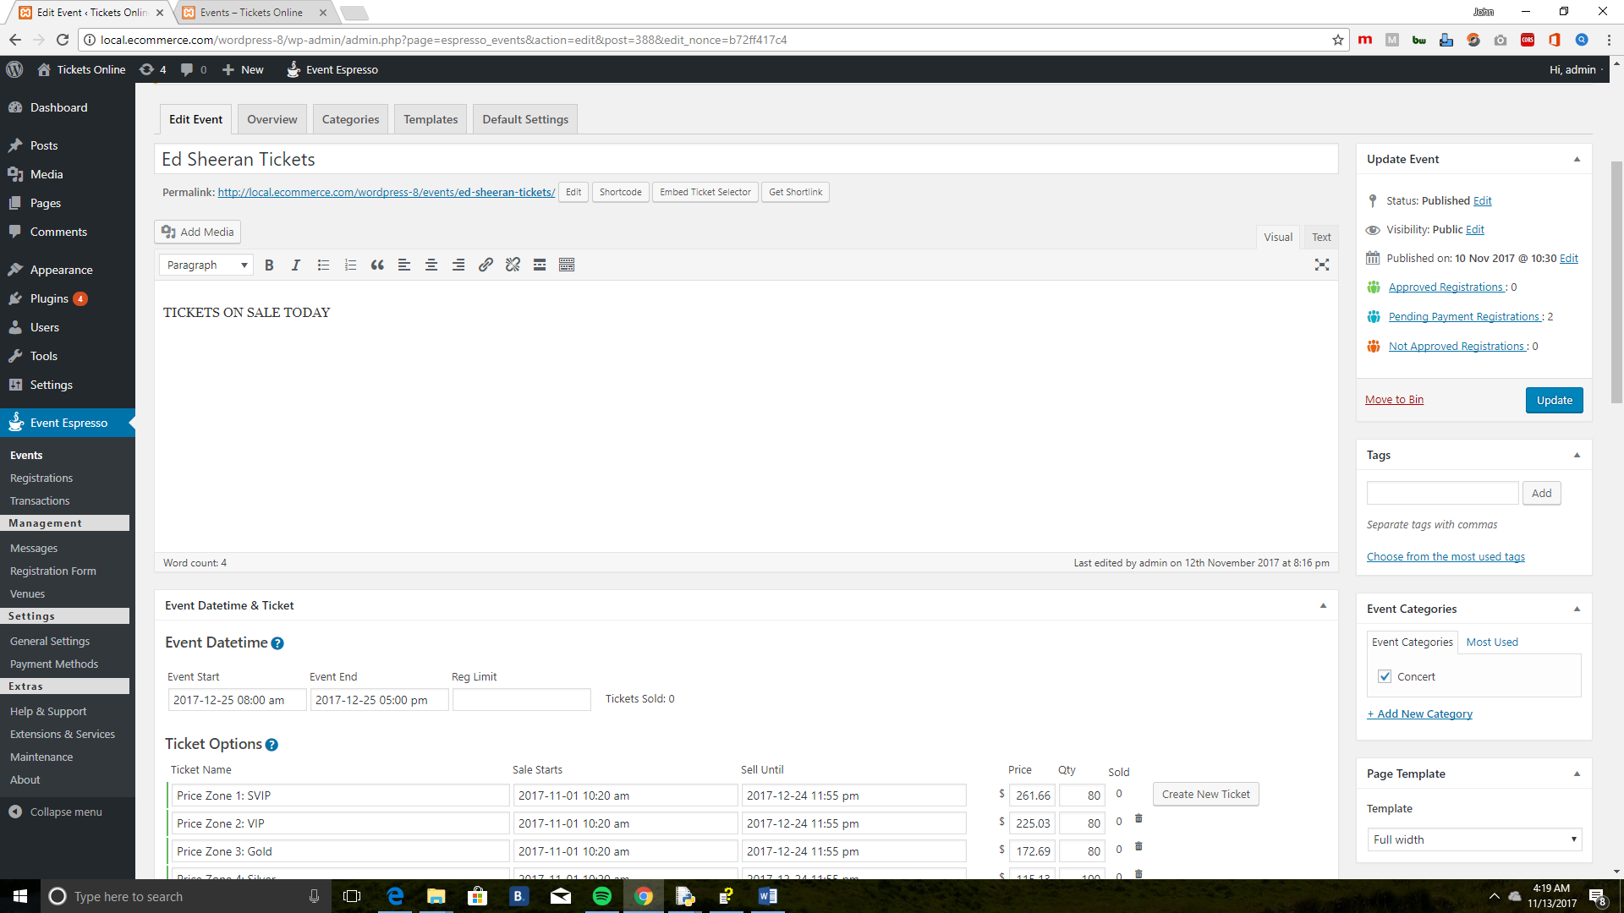

**Edit Event** : Add the title of an event.

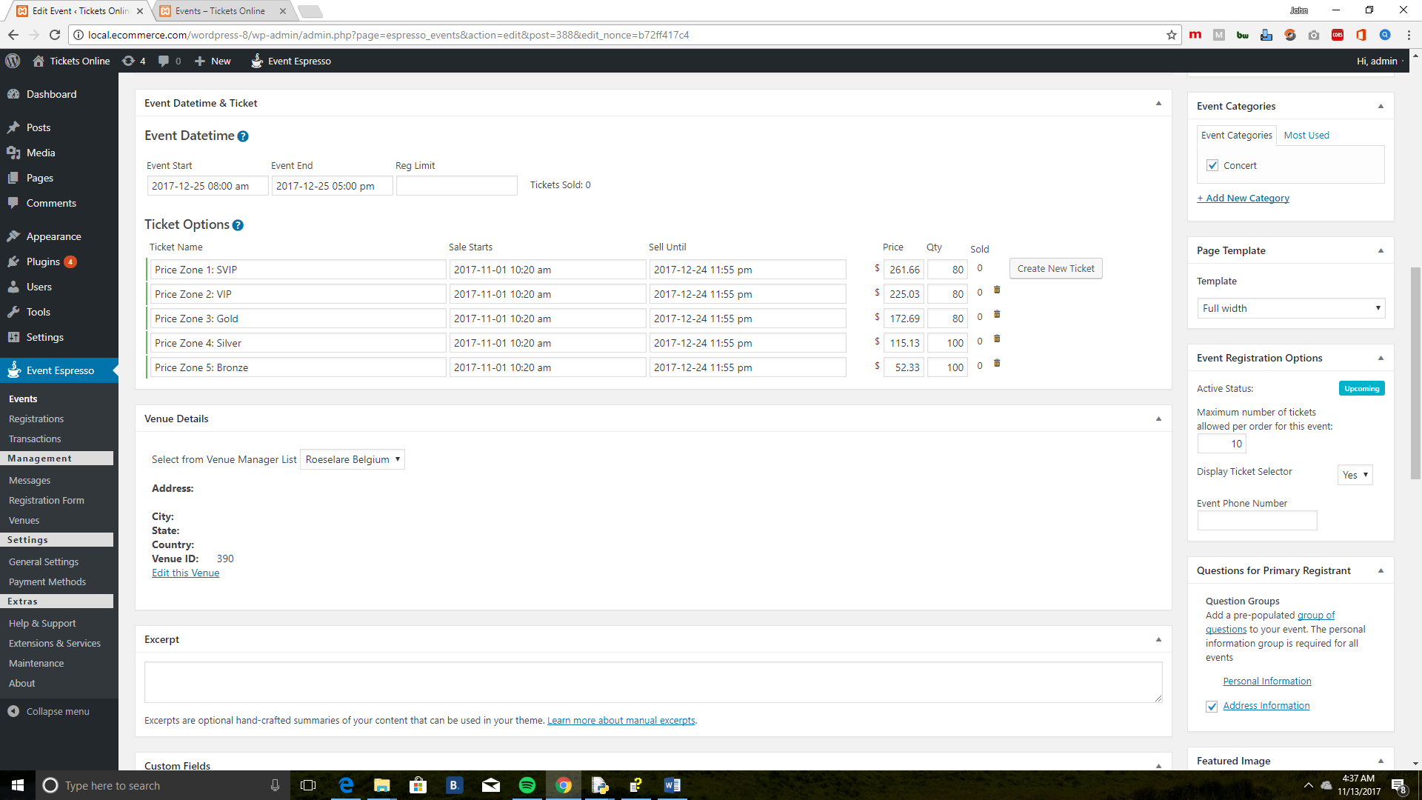

1. **Event Datetime & Ticket**
   * Event Start: Set Date and time for start event
   * Event End: Set Date and time for end event
   * Reg Limit
2. **Ticket Options**

* Ticket Name: Set Ticket Name
* Sale Starts: Set start sales of tickets
* Sell Until: Set end sales of tickets
* Price: Set ticket price
* Qty: Set available ticket quantities
* Sold: Tell if tickets is sold or not

1. **Venue Details**

* Select from Venue Manager List: Select created venue from list
* Address
* City
* State
* Country
* Venue ID

1. **Featured** **Image** : Set Images for ticket

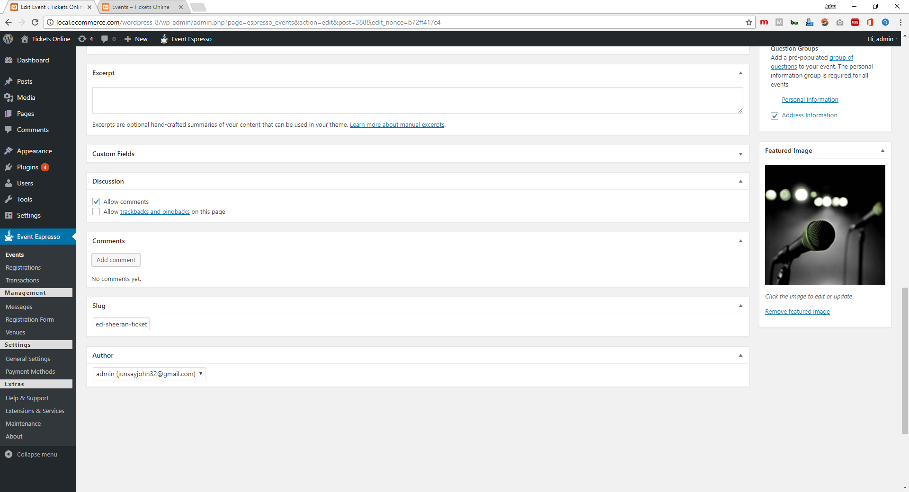

1. **Event Registration Options**

* Active Status: Tell the status of an event if upcoming or not
* Maximum number of tickets allowed per order for this even: Set allowed limit tickets per order
* Display Ticket Selector: YES/NO
* Event Phone Number: Contact number for event

1. **Update Event** : Saves or Update and Created Event

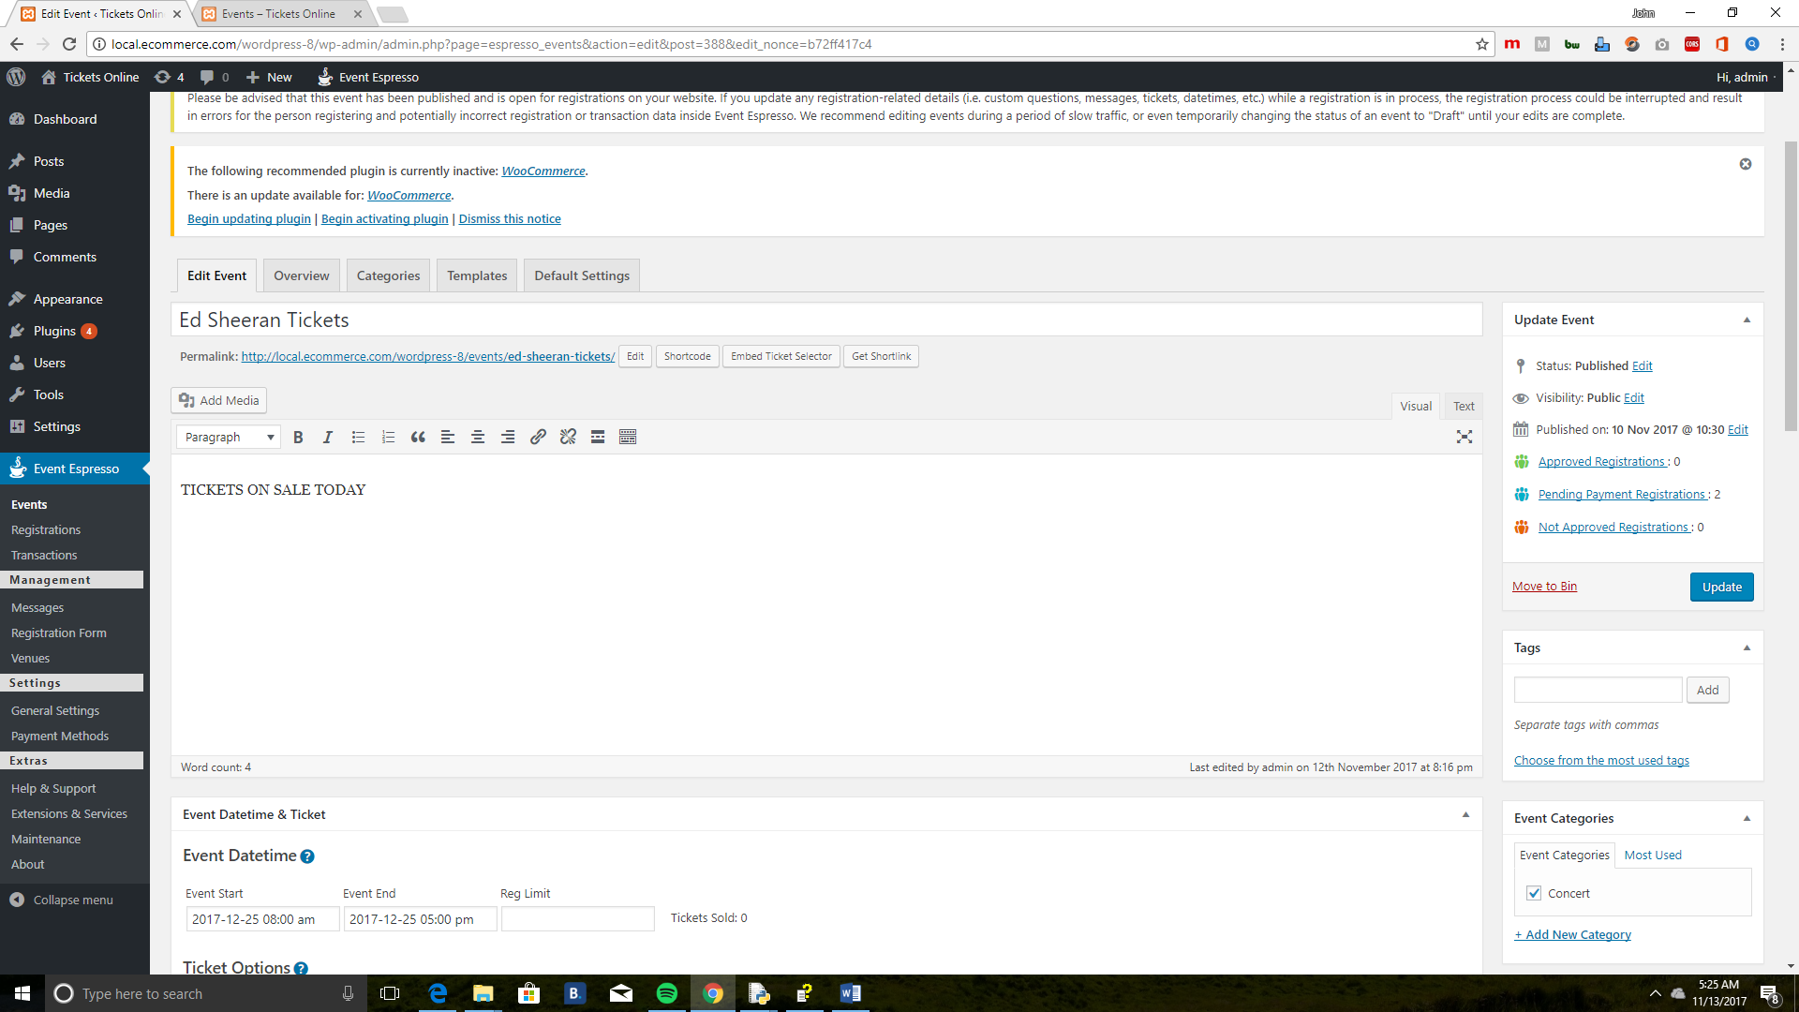

**Overview** : Shows Lists of created events.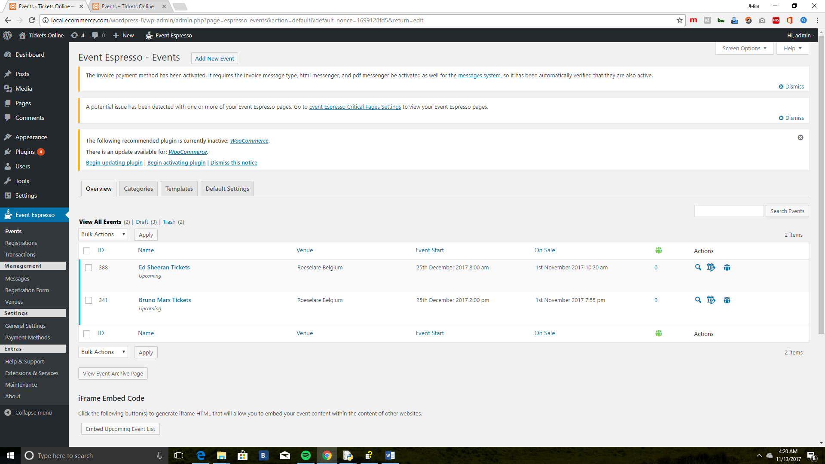

**Categories**: Lists the categories assigned for each events.

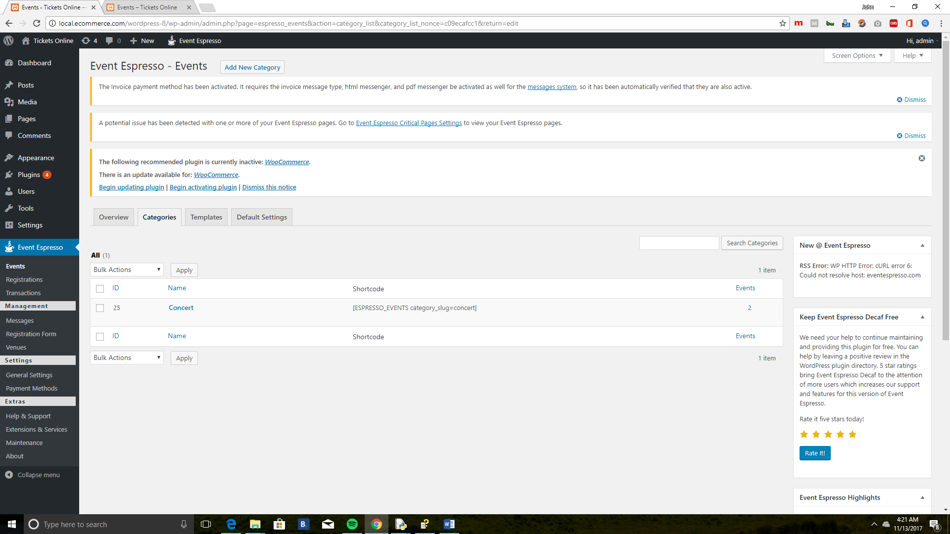

**Templates** :

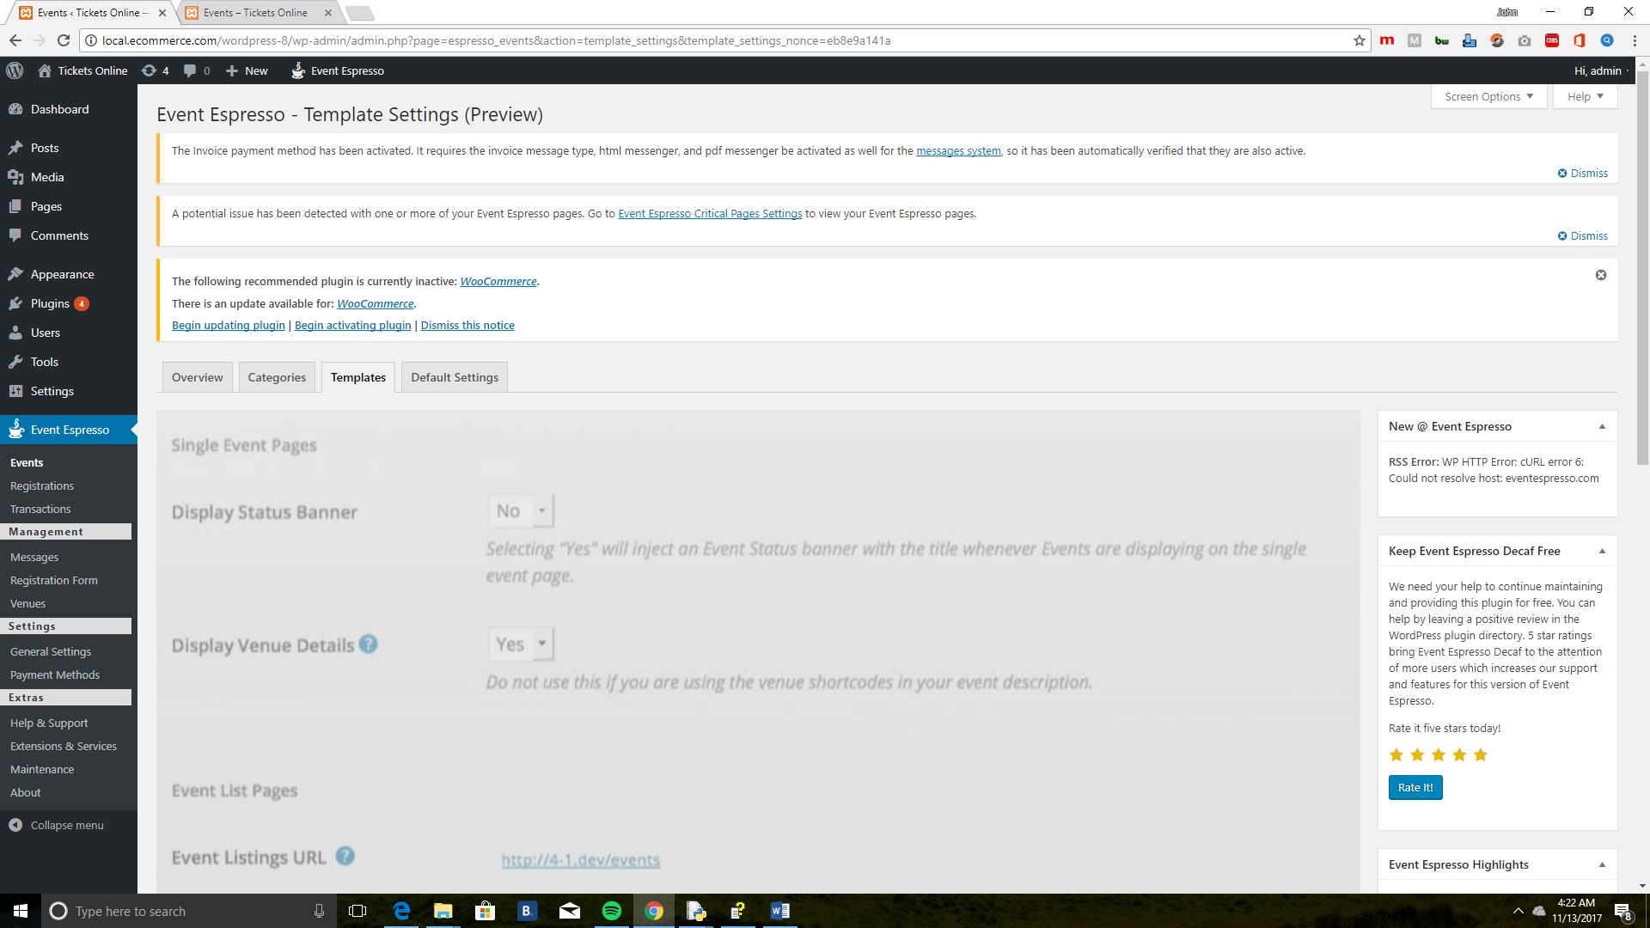

**Default Settings**

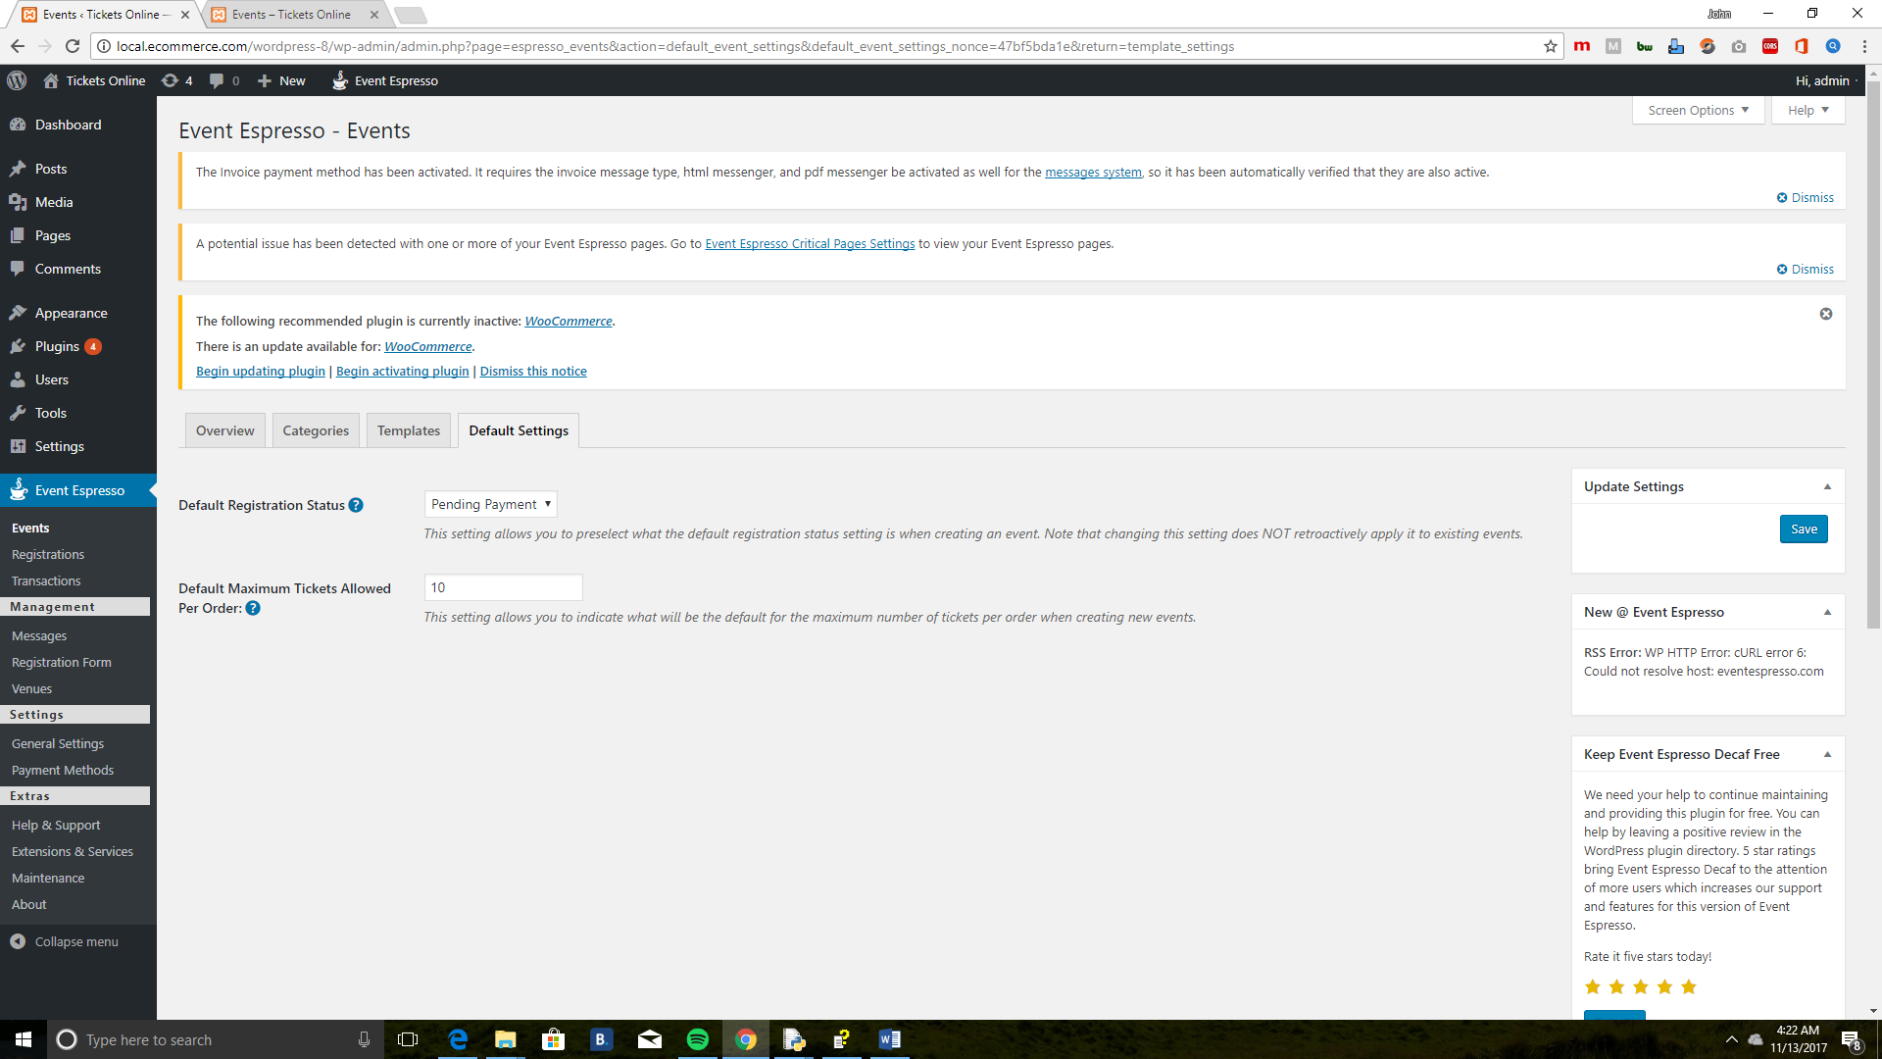

**Registra****tion**

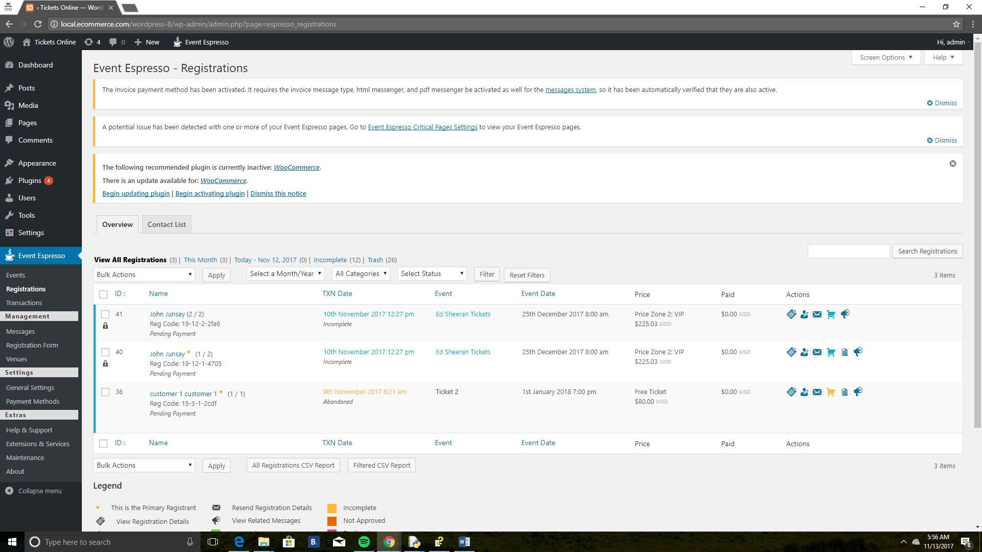

1. **ID**: View Registration id can be stored in ascending or descending order.
2. **Name**: View the name of registrant. Can be sorted in ascending or descending order.
3. **TXN DATE**: View the name of registrant. Can be sorted in ascending or descending order.
4. **View the name of the event**. Can be sorted in ascending or descending order.
5. **View the date of the event**. Can be sorted in ascending or descending order.
6. **Price**: Price of the registration.
7. **Actions**: Perform an action to a registration. See legend in bottom left corner.
8. **Legend**: This is the legend that describes the actions available in the actions column. Also shows available status for a registration.
9. **View all registrations**: You can select different views by time period or look at registration which have been remove to the trash.
   * **Bulk Actions**: Perform a bulk action to a multiple registrations.
   * **All Categories**: Registration can be filtered by date, categories or status.
10. **Search Registrations**: Search through registrations. The following will be searched. Event Name, Event Description, First Name, Last Name, Biography, Email Address, Address Comments, Notes, Registration Final Price, Registration Code, Registration Group Size, Ticket Name, and Ticket Description.

**Transactio****ns**

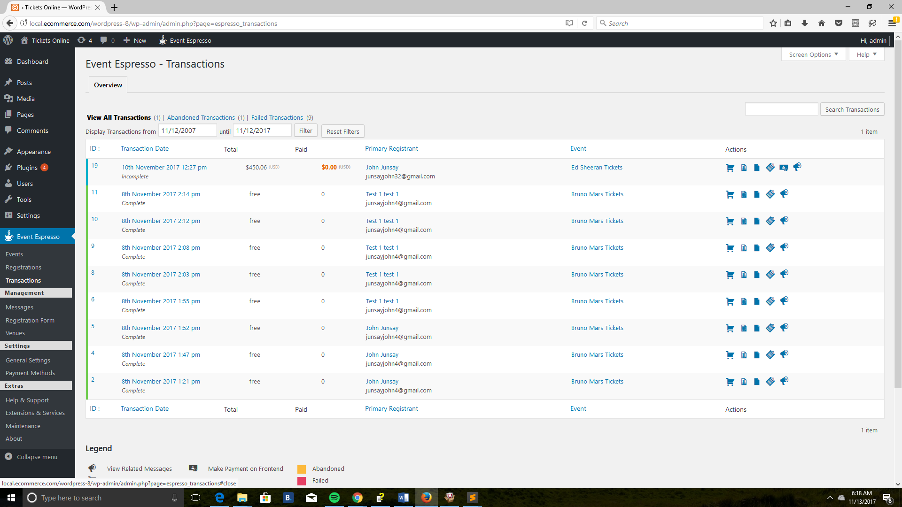

1. **ID**: View transaction id. can be stored in ascending or descending order.
2. **Transaction** Date: View transaction date. can be stored in ascending or descending order.
3. **Total**: View total for transaction.
4. **Paid**: View amount paid for transaction.
5. **Primary Registrant**: View name for the primary registrant. can be stored in ascending or descending order.
6. **Event**: View name of event. can be stored in ascending or descending order.
7. **Action**: Perform an action to a registration. See legend in bottom left corner.
8. **Legend**: This is the legend that describes the actions available in the actions column. Also shows available status for a registration.
9. **View all registrations**

* **Abandoned transaction**: Filter transactions by date by selecting two dates and clicking on the filter button. You can clear your current date selection by clicking on the reset filters button.

1. **Search Registrations**: Search through registrations. The following will be searched. Event Name, Event Description, First Name, Last Name, Biography, Email Address, Address Comments, Notes, Registration Final Price, Registration Code, Registration Group Size, Ticket Name, and Ticket Description.

­

**Mes** **sages**

1.Message Activity

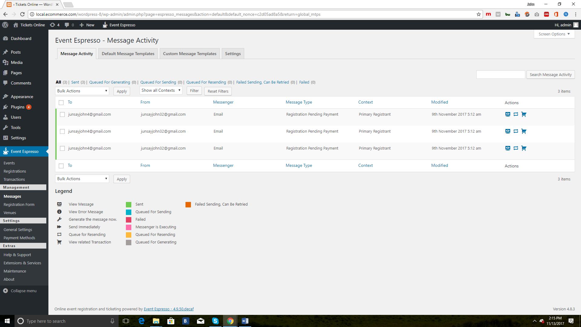

2. **Default Message Templates**

* **Message type**: View of the message can be stored in ascending or descending order.
* **Messenger**: View who message will be sent. can be stored in ascending or descending order.
* **Description**: View the description for each message type.
* **Show All Messengers**: You can filter by different notifications by making a selection below and clicking on the filter button. To reset your selection, just click on the reset filters button.

3. **Custom Message Templates**

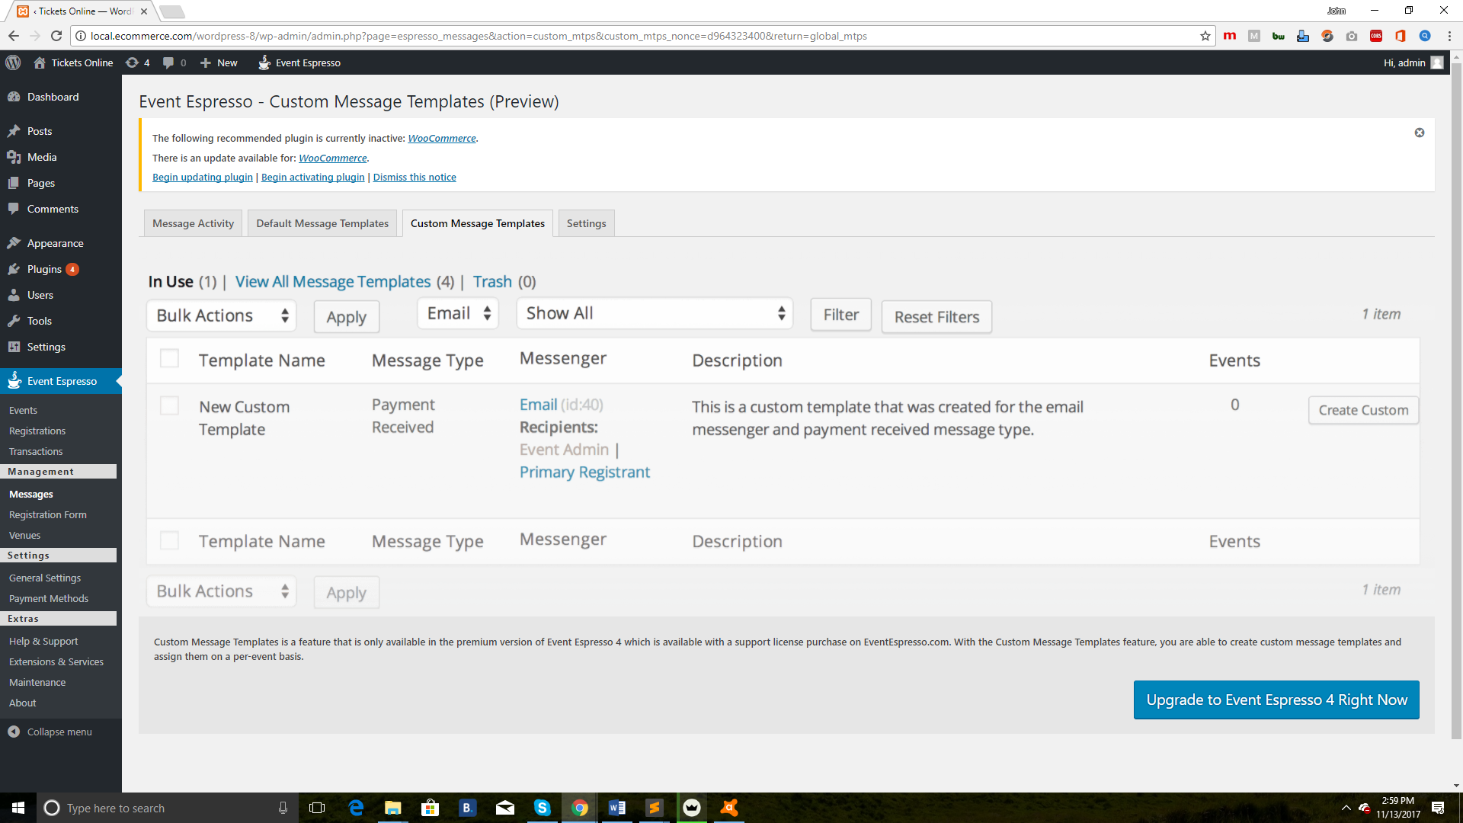

4. Settings

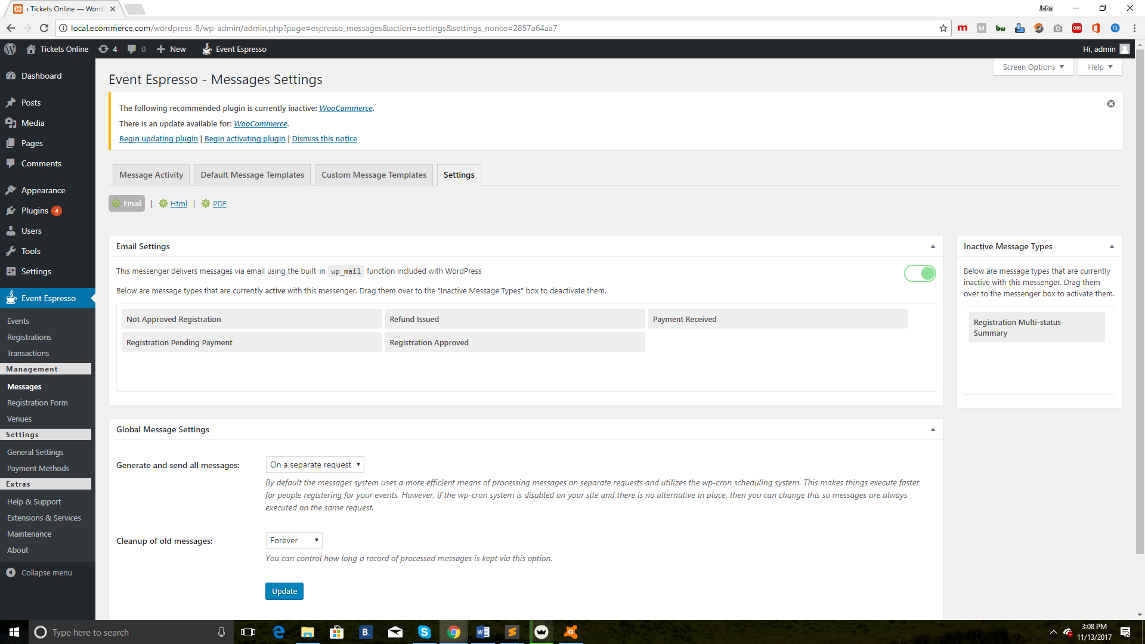

* **Email**: Available Messenger are shown above.
* **Email Settings**: View the different message types that are currently active.
* **Not Approved Registration**: These are your active message types. Click them to see a description and settings for each one.
* **Registration Multi-status Summary**: Drag message types here to deactivate them. Drag them from here to active box to reactivate them.

**Registr****ation Form**

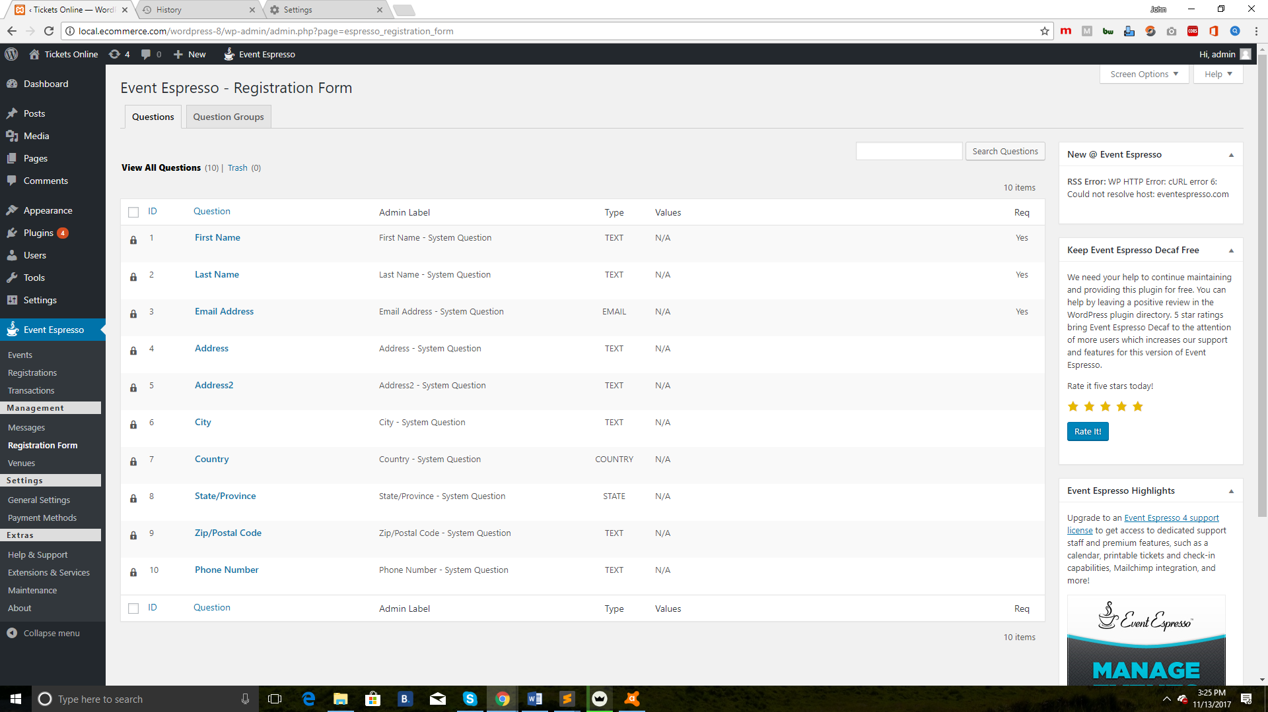

**Ven****ues**

* **Overview**

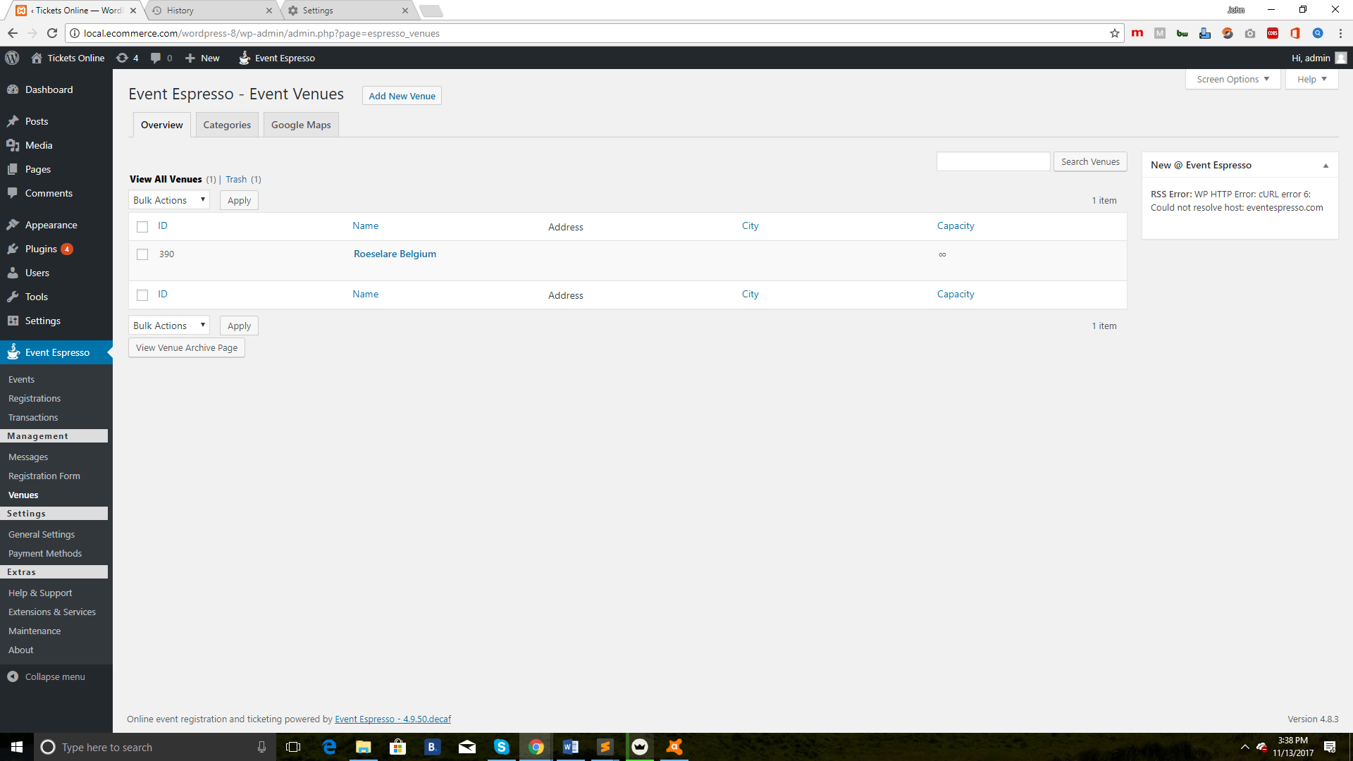

* **Categories**

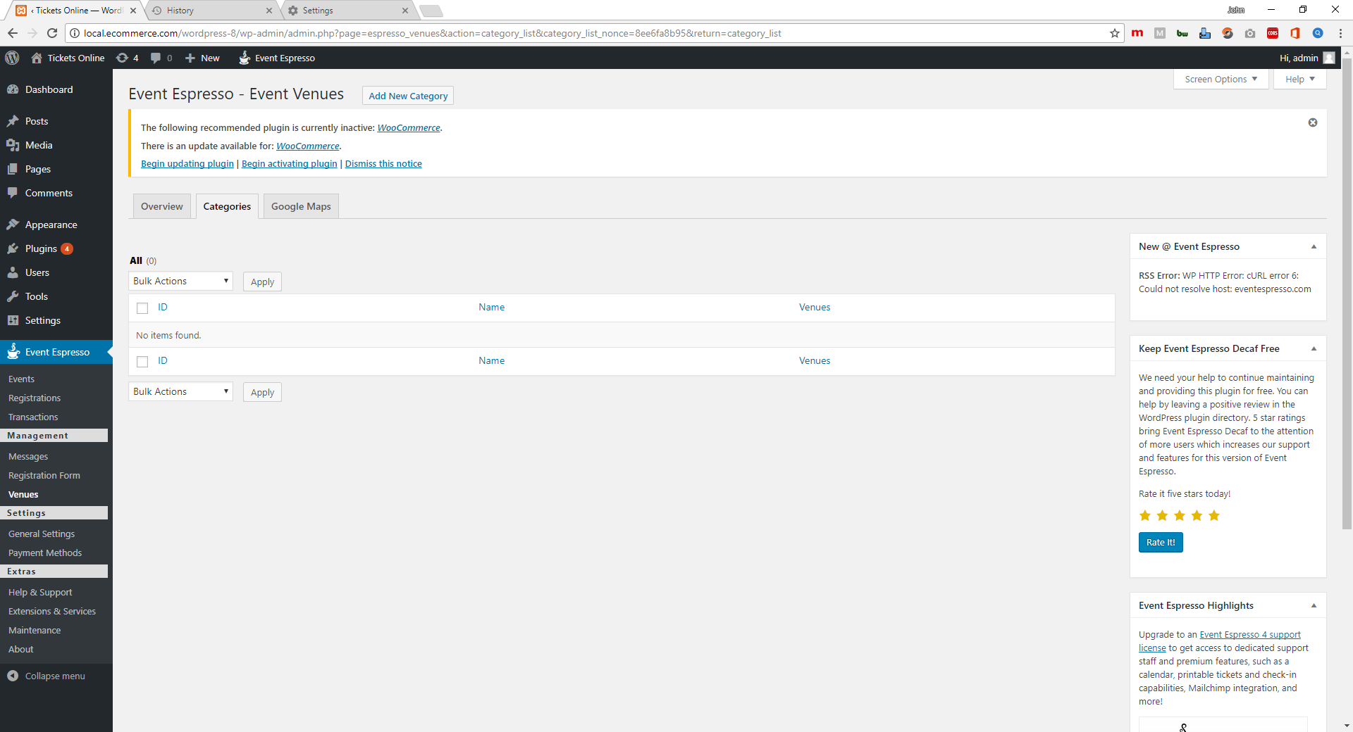

* **Google Maps**

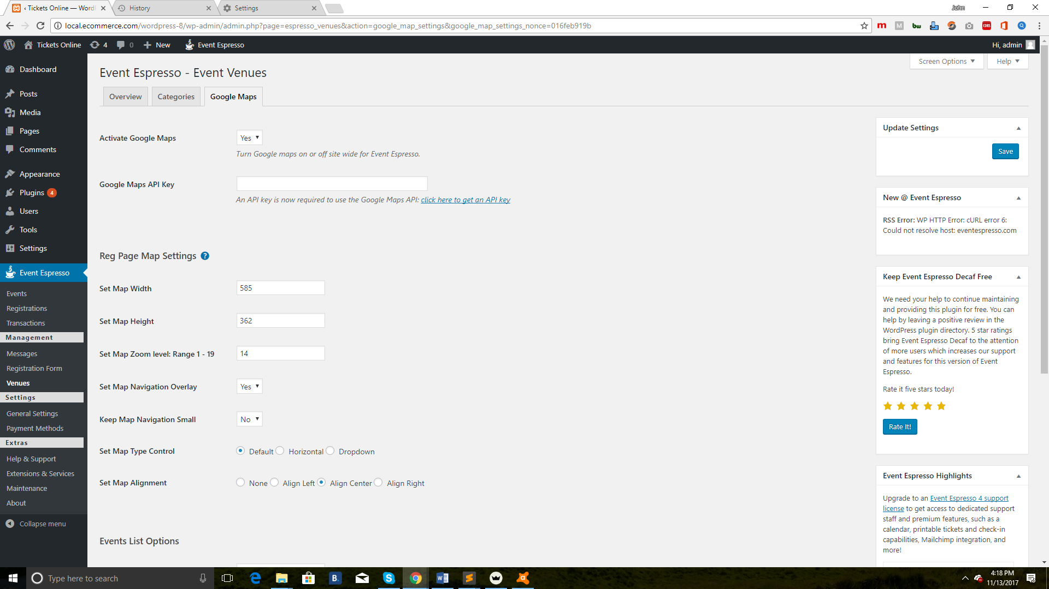

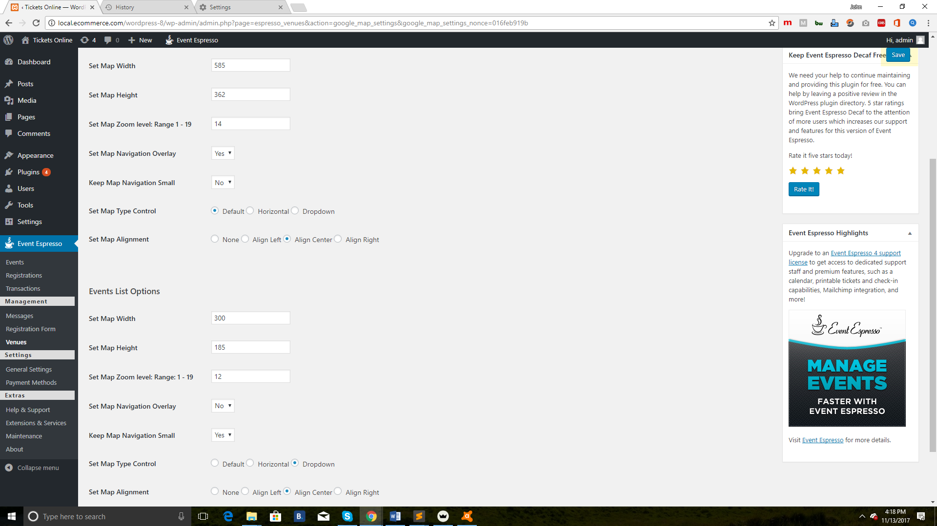

* **Activate Google Maps**: Turn google maps on or off site wide for Event Espresso.
* **Reg Page Map Settings**
  + **Set Map Width**: These settings affect the single registration pages map only.
* **Event List Option**
  + **Set Map Width**: These Settings affect the event list page.

**Gene****ral Settings**

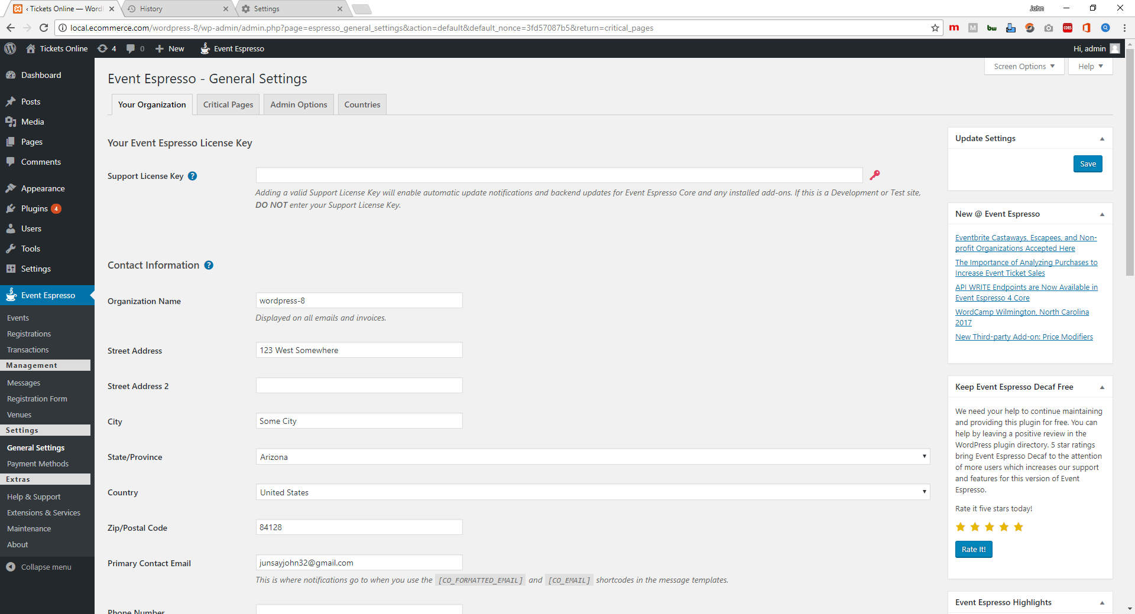

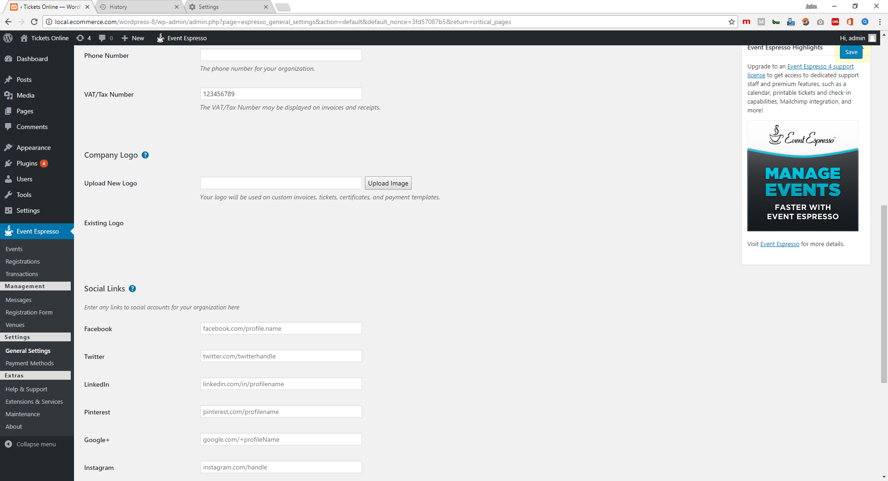

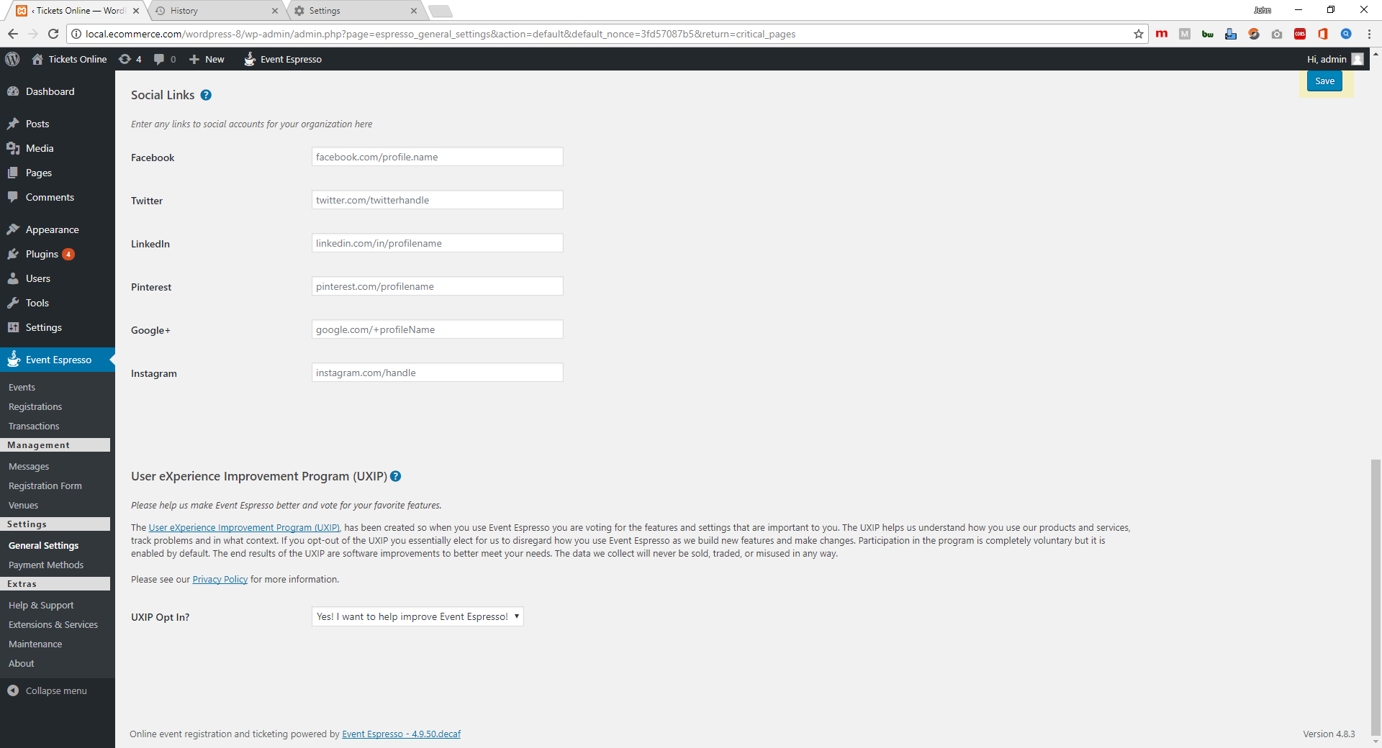

* **Your Organization** 
  + **Support license key**: Enter your support license key here to enable one-click updates.
  + **Contact Information**: You can change your business / organization information below. Be sure to keep this information updated as it is used in other areas of the site. Adjusting the country option here will update your currency settings. More options are available in the Countries tab. tab.
  + **Upload New Logo:** Add a logo. This can be used for invoices and tickets.
  + **Facebook**: Add links to various social media networks
  + **UXIP Opt In? :** Help us to help you! Sign up to the User eXperience Improvement Program and send us anonymous data that will help us improve Event Espresso.
  + **Save**: You are almost done updating Your Organization information. Click on the Save button to save changes and then go to the Payment Methods screen so you can setup a payment gateway.

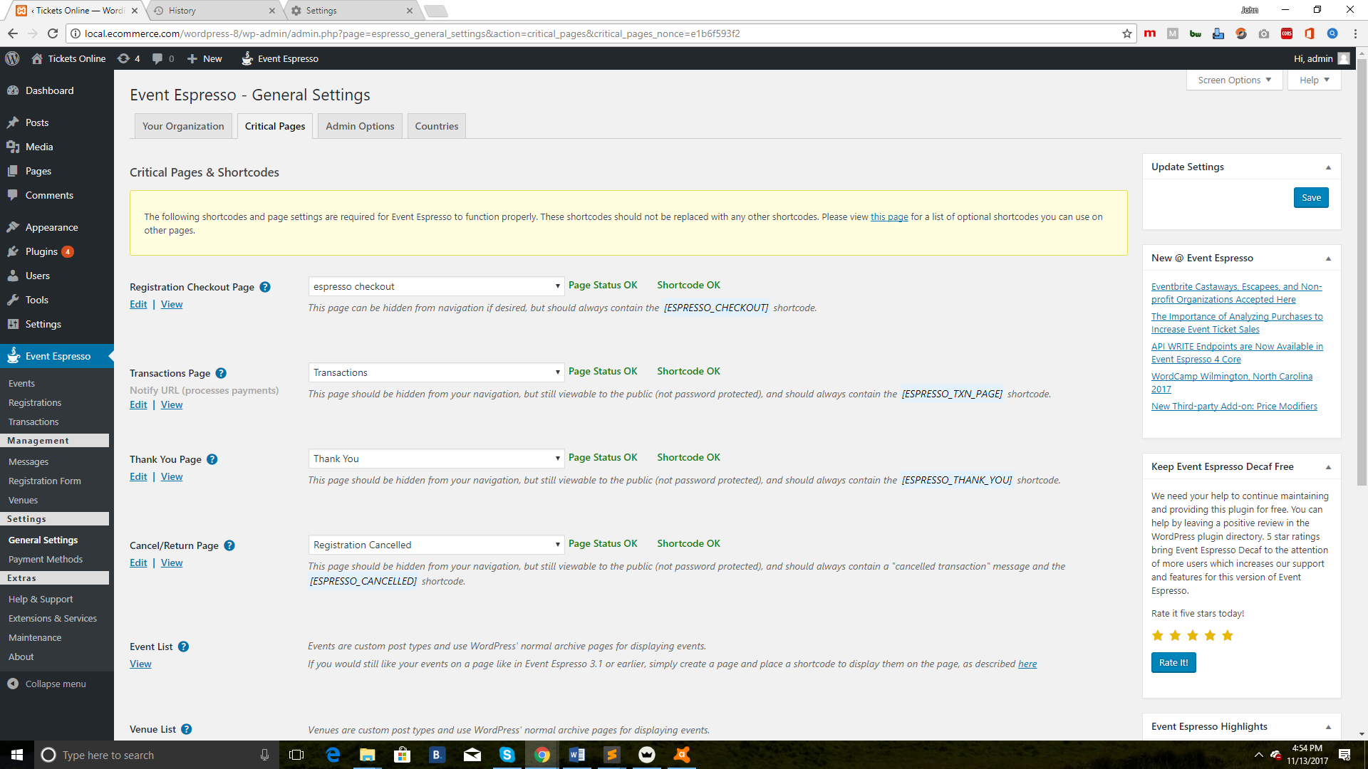

* **Critical Pages**: This section lists the pages that Event Espresso needs in order to function. Should you wish to change a page that is used you will need to move the shortcode to the the new page and then allocate it here. Otherwise your registrations will not work correctly.

This section also provides a status of the page to show you at a glance if something is not right.

* Checkout Registration Page: This page processes the registrations and is required, even if it is not visible in your menus.
* **Transactions Page:** This page processes payments. It should not be visible on your menus, and the page should not contain anything other than the shortcode.
* **Thank You Page:** This page is displayed after a successful transaction. Feel free to add extra content to this page to personalise it!.
* **Cancel/Return Page:** This page is displayed after an unsuccessful transaction. Feel free to add extra content to this page to personalise it!

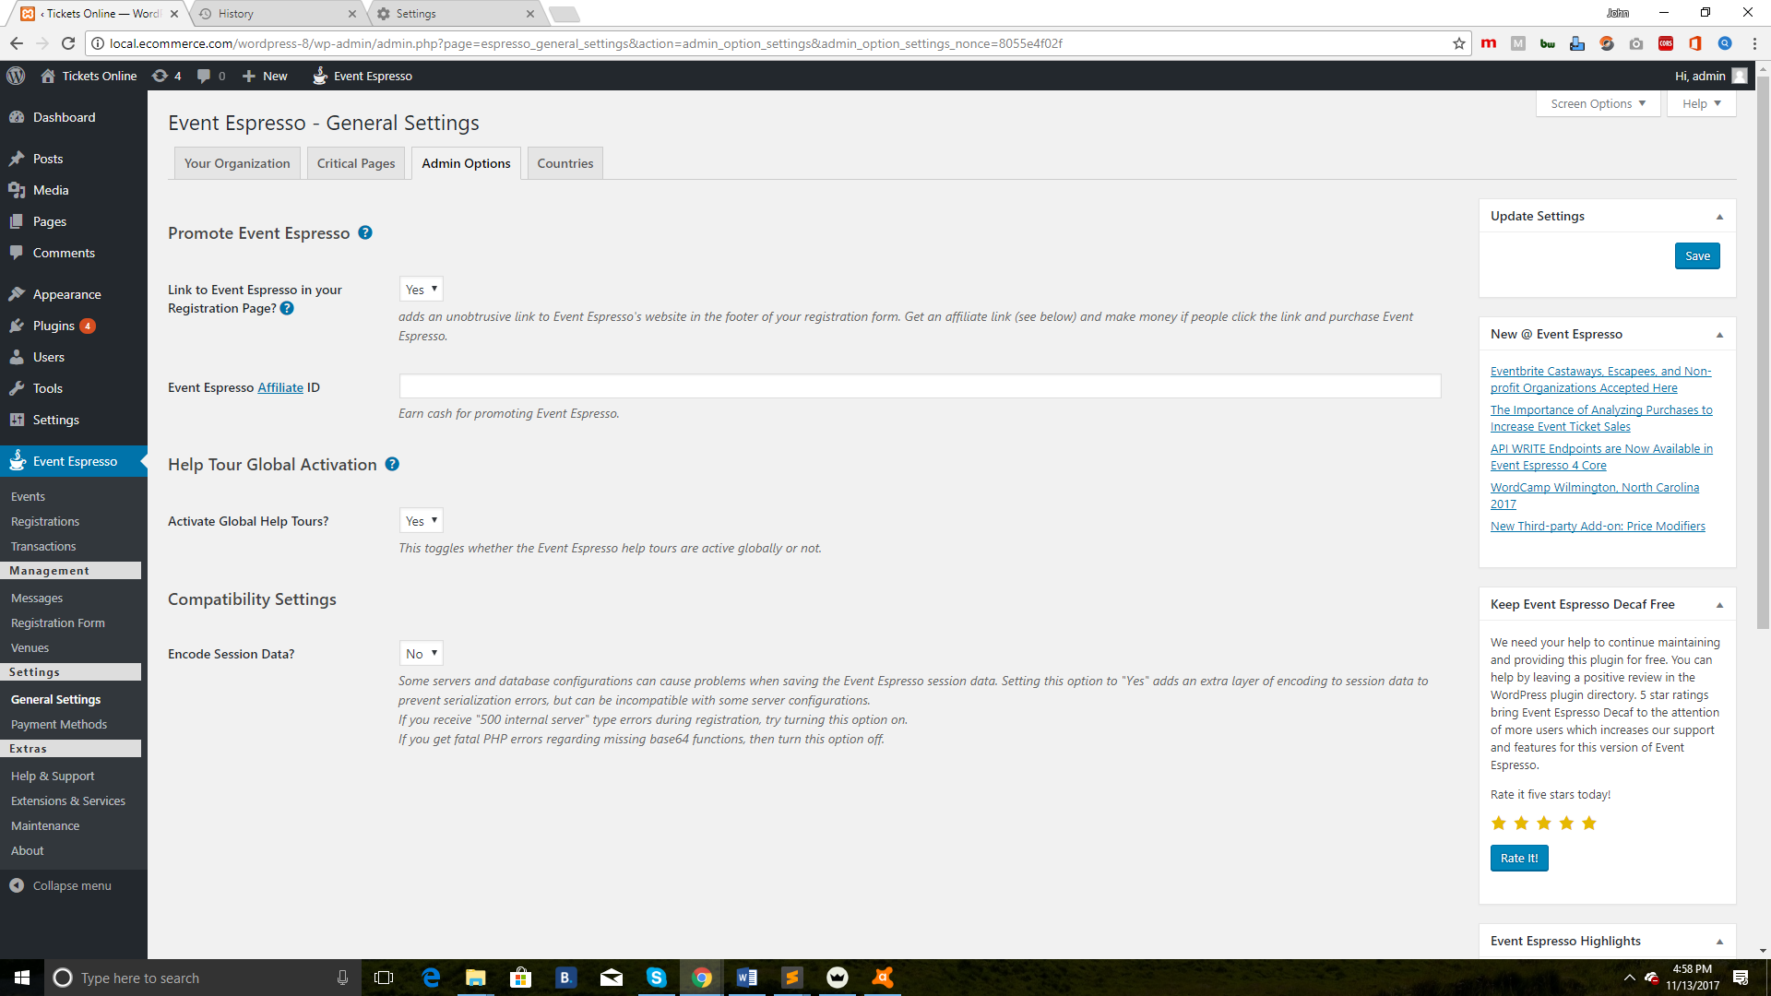

* **Admin Options:** 
  + **Promote Event Espresso**: Support us by adding a small link to Event Espresso in your event pages. You can even earn money for yourself by adding your affiliate link there!.
  + **Help Tour Global Activation**: Turn these help tours on / off for Event Espresso pages.

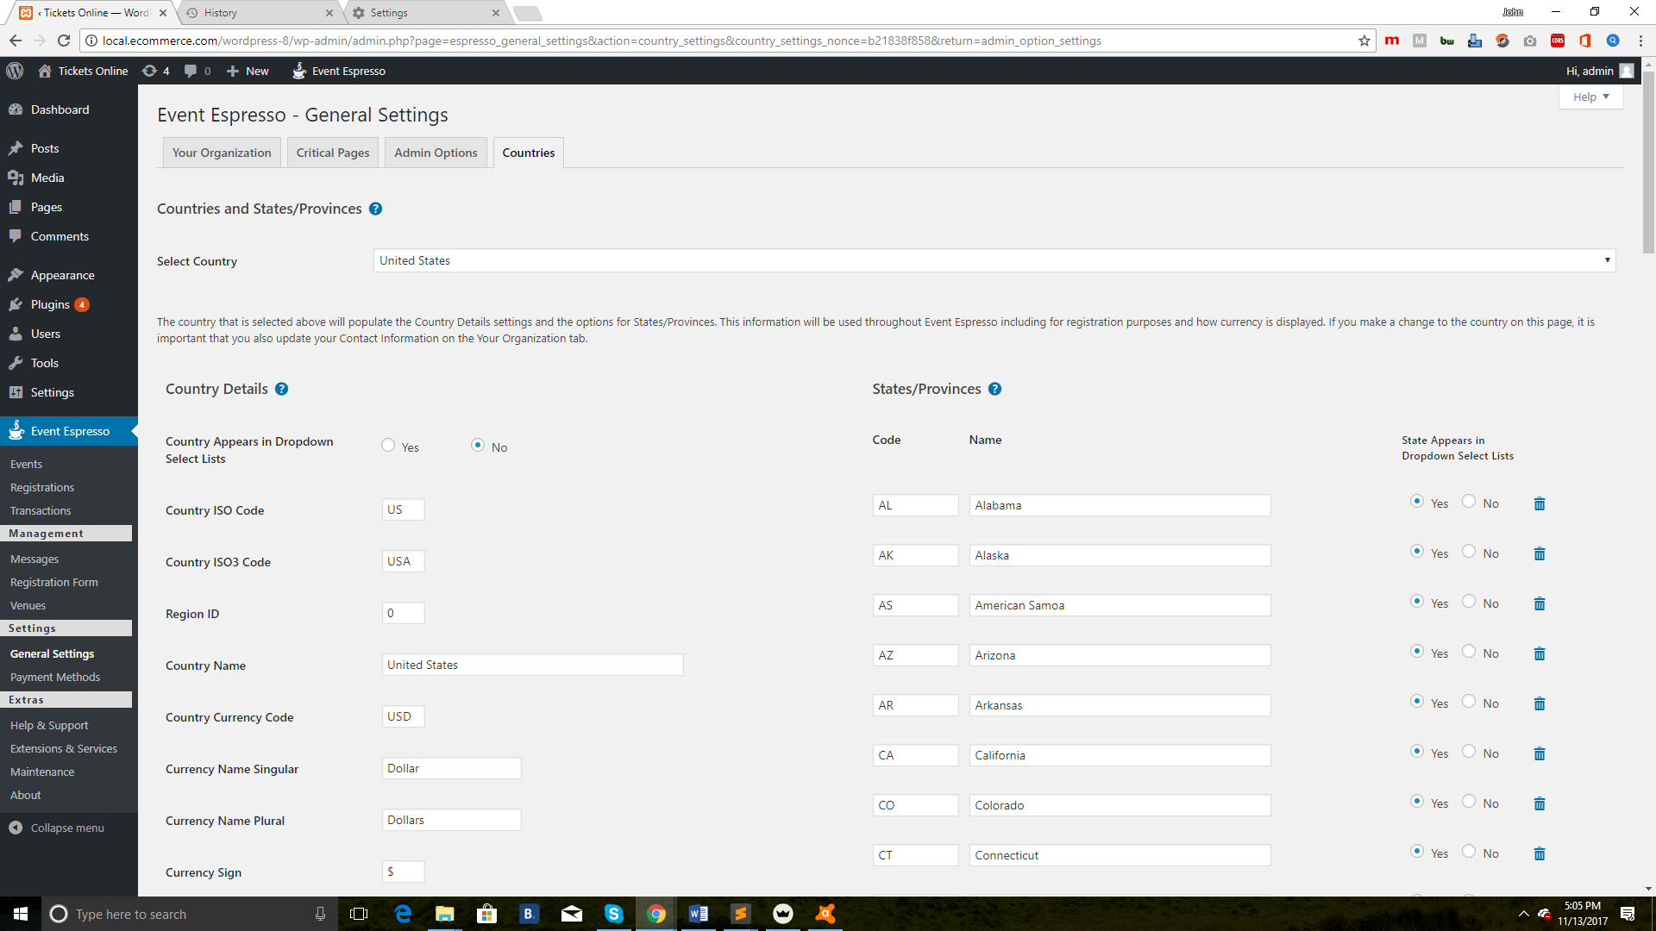

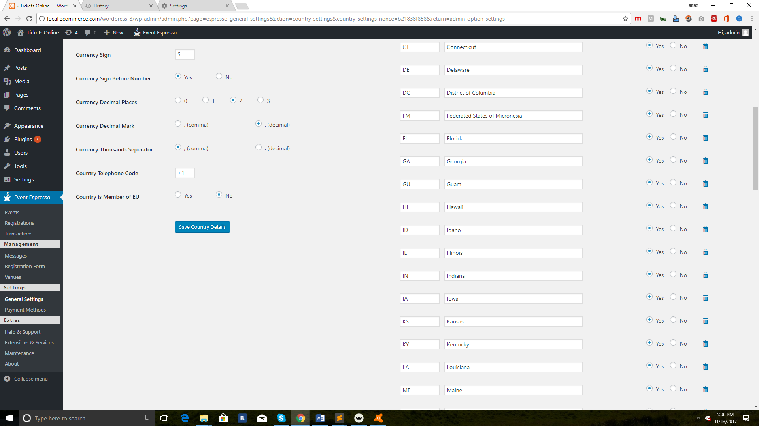

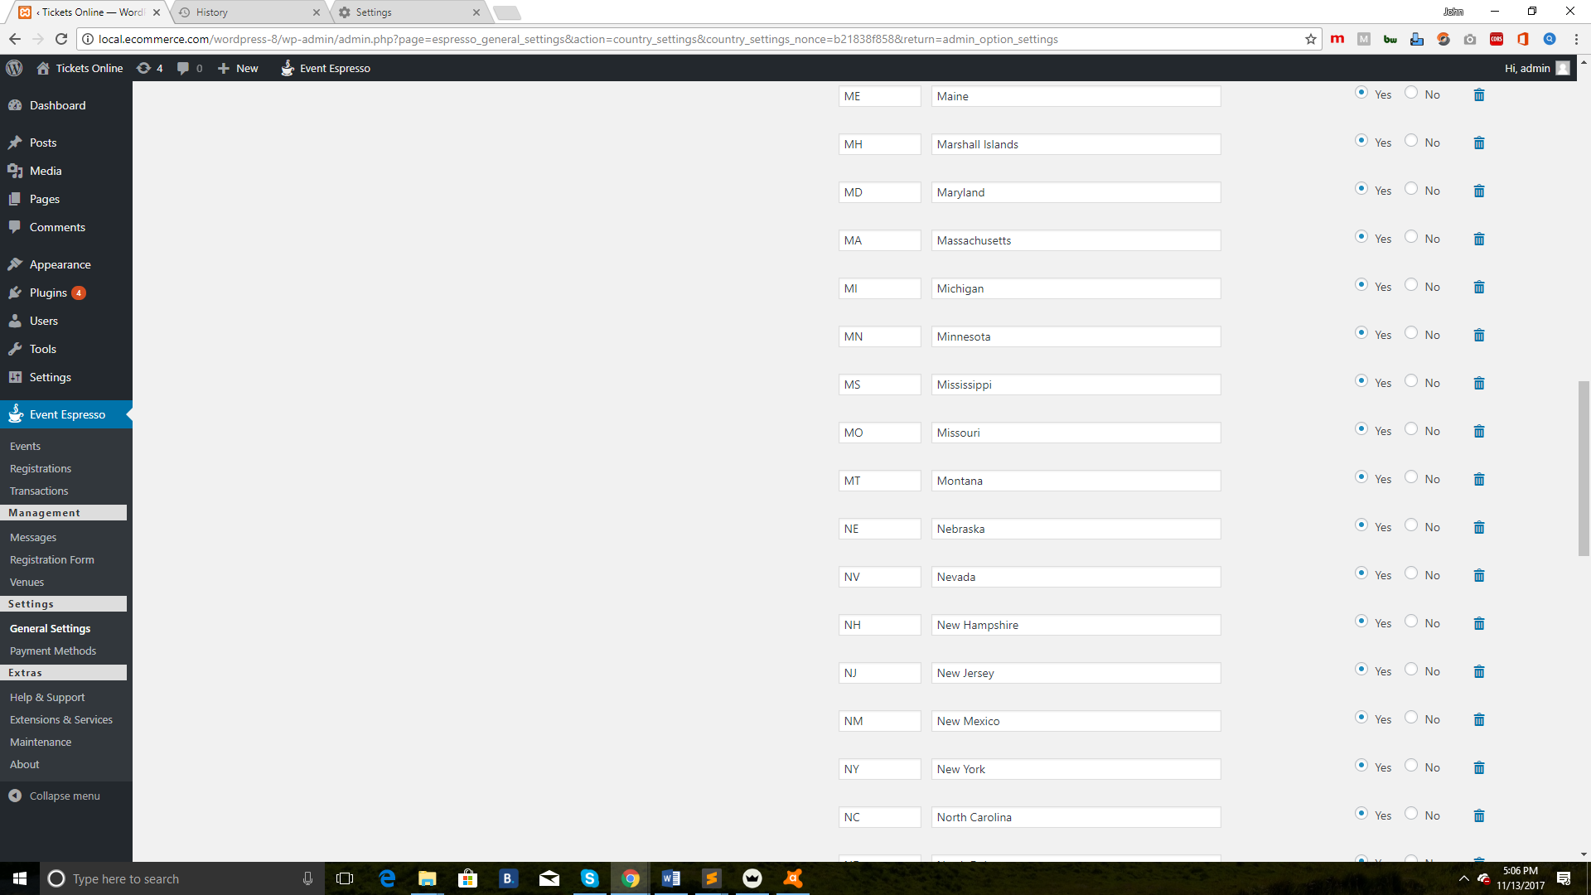

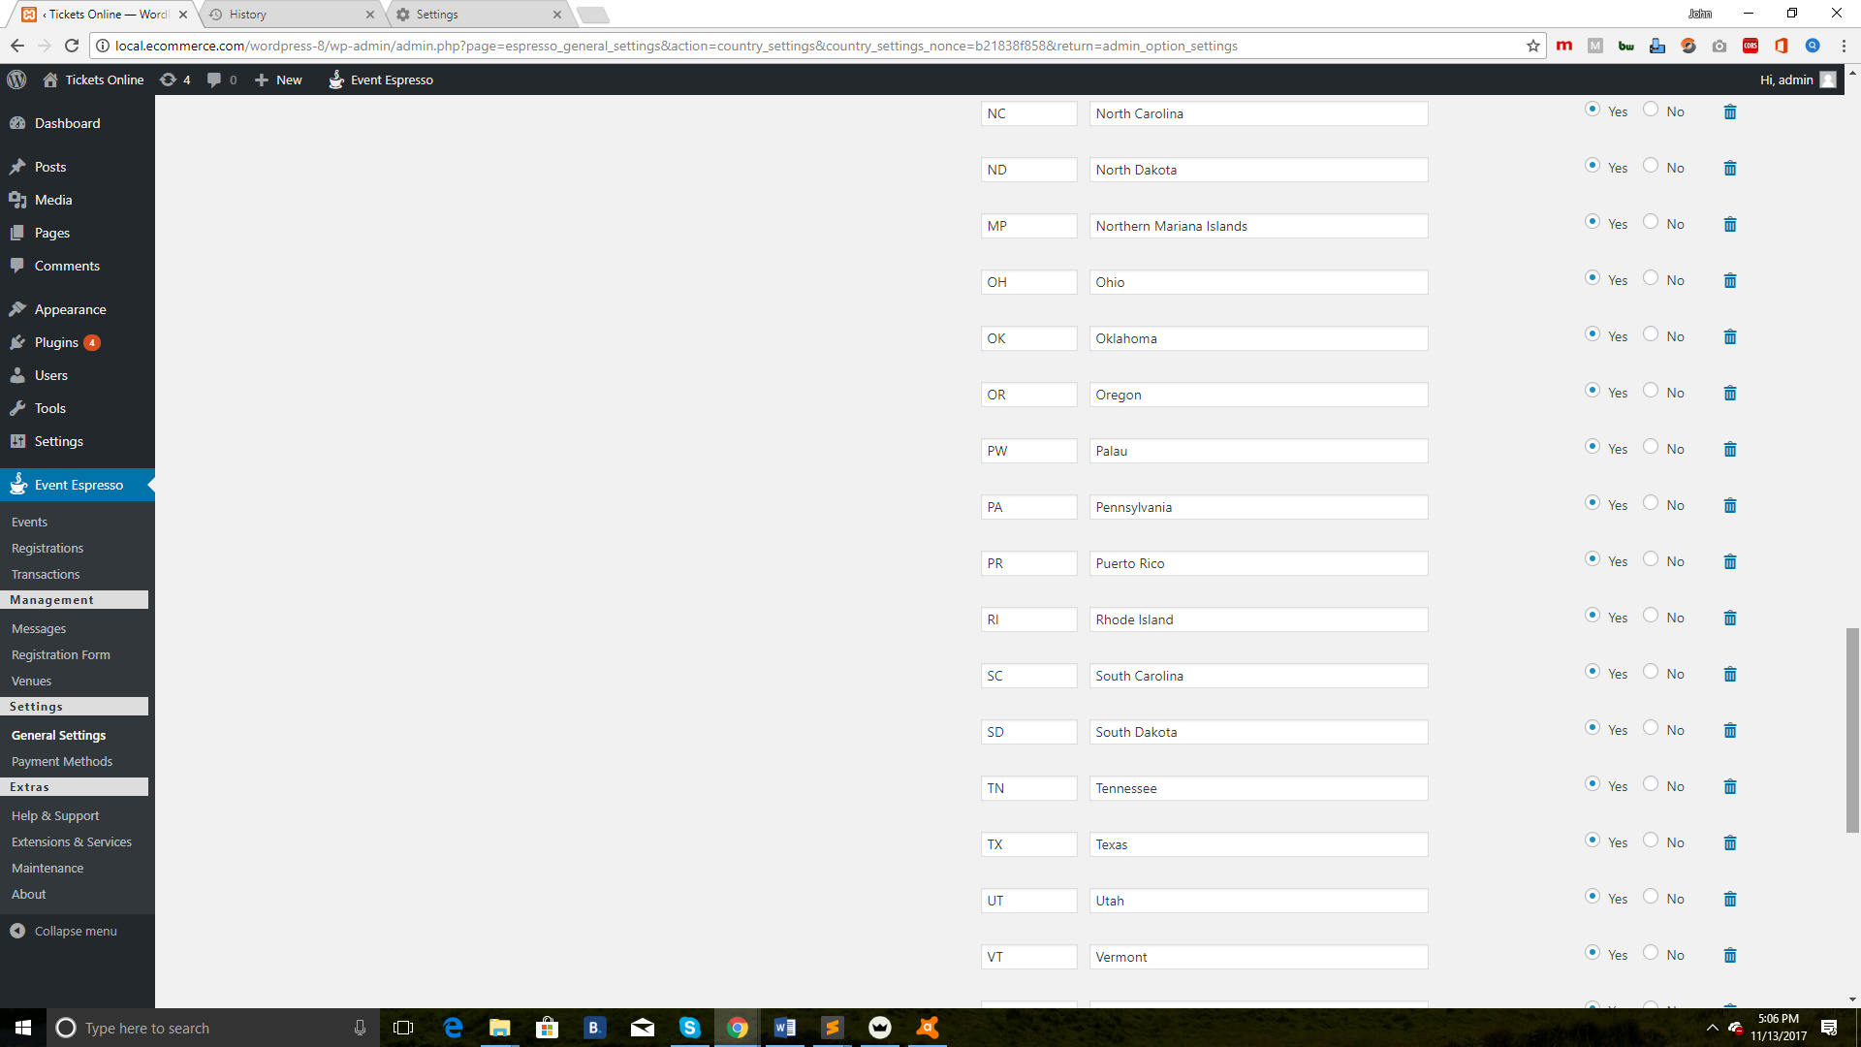

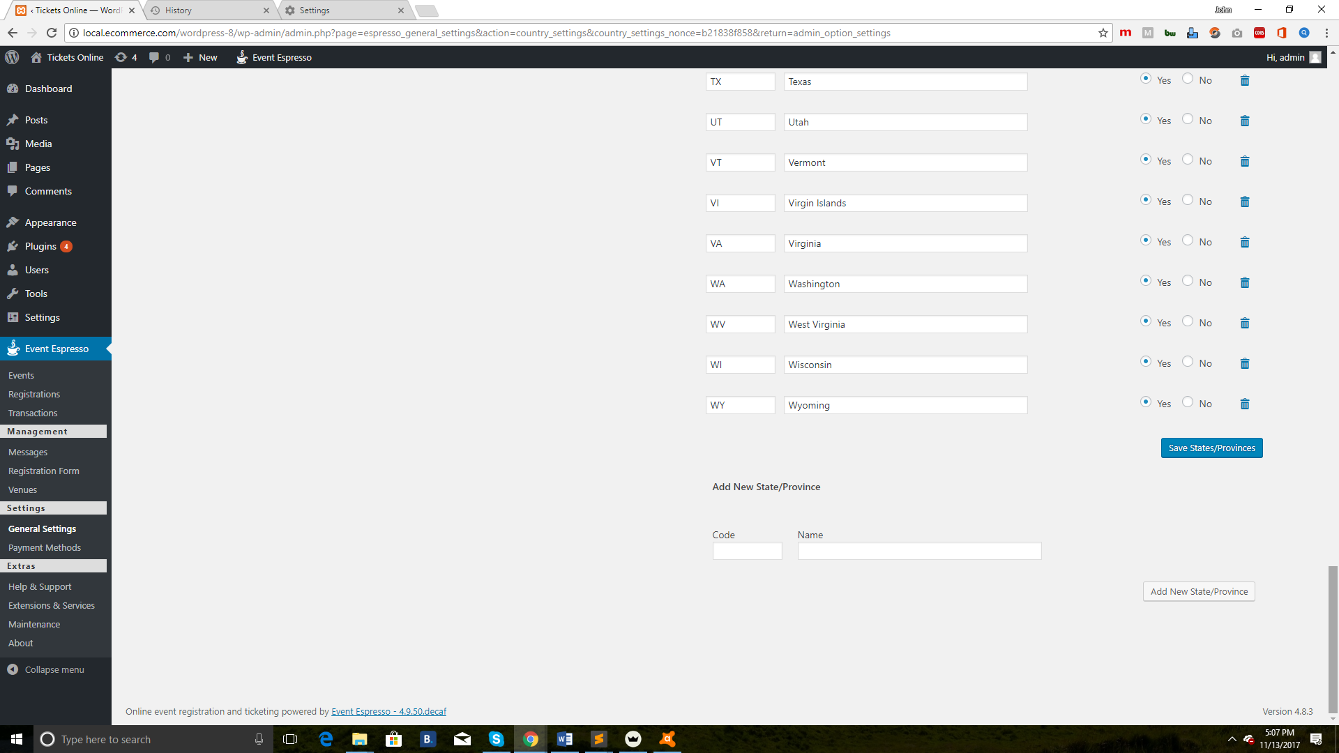

* **Countries**:
  + **Select Country**: Select the country where your business or organization is located. This affects the currency that is used in Event Espresso.
  + **Country Details**: Here you can fine tune country and currency settings.
  + **State/Provinces**: Used in certain areas of the plugin, here you can define what states/provinces will be displayed in case you do not do business in certain areas.

**Payment M****ethods**

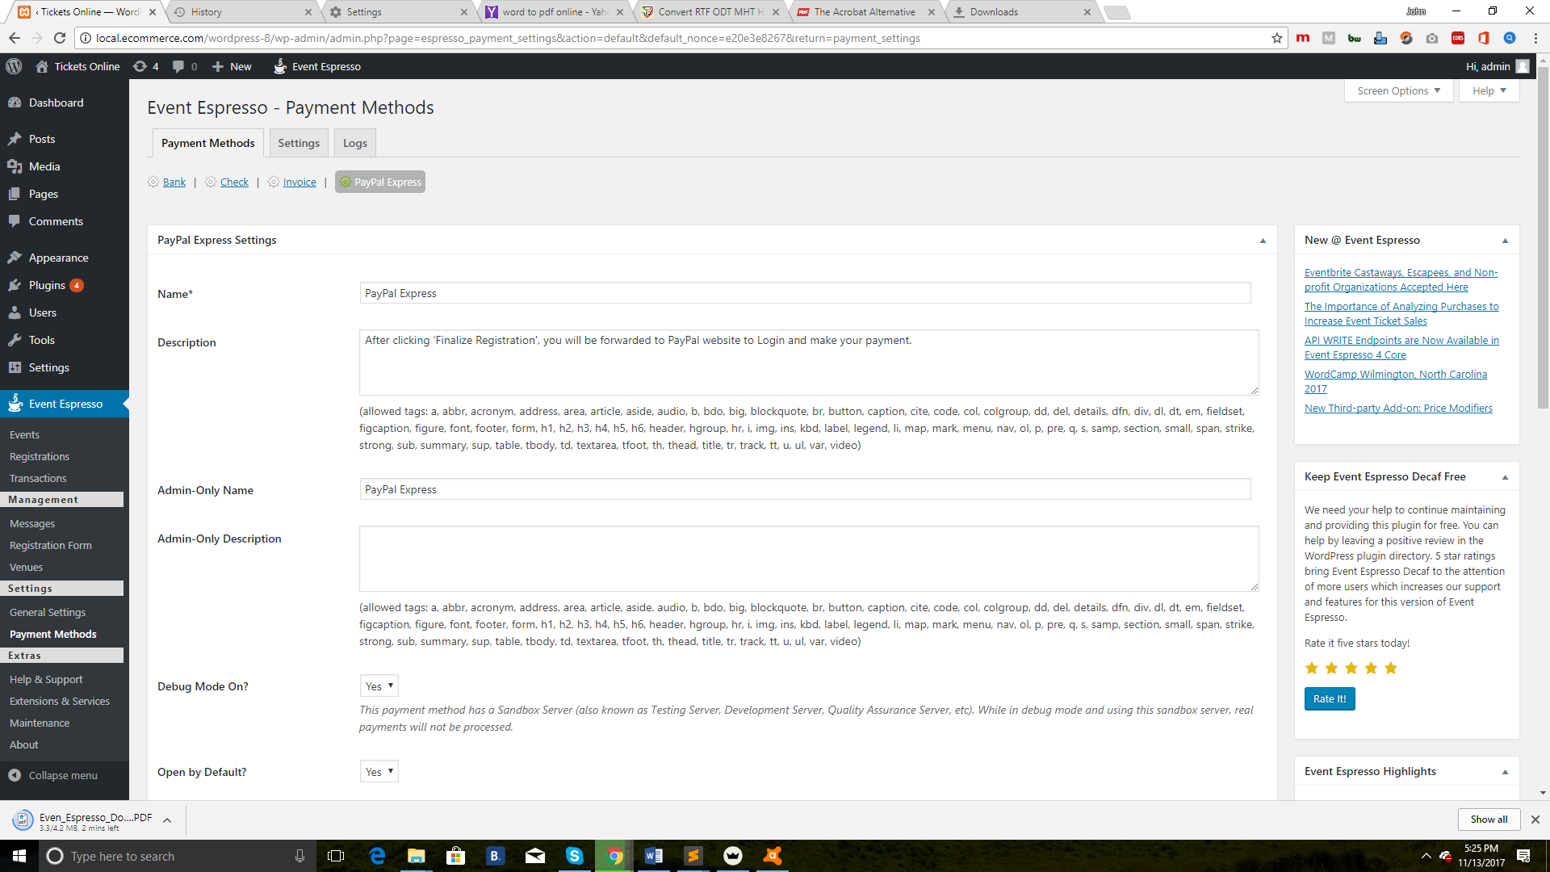

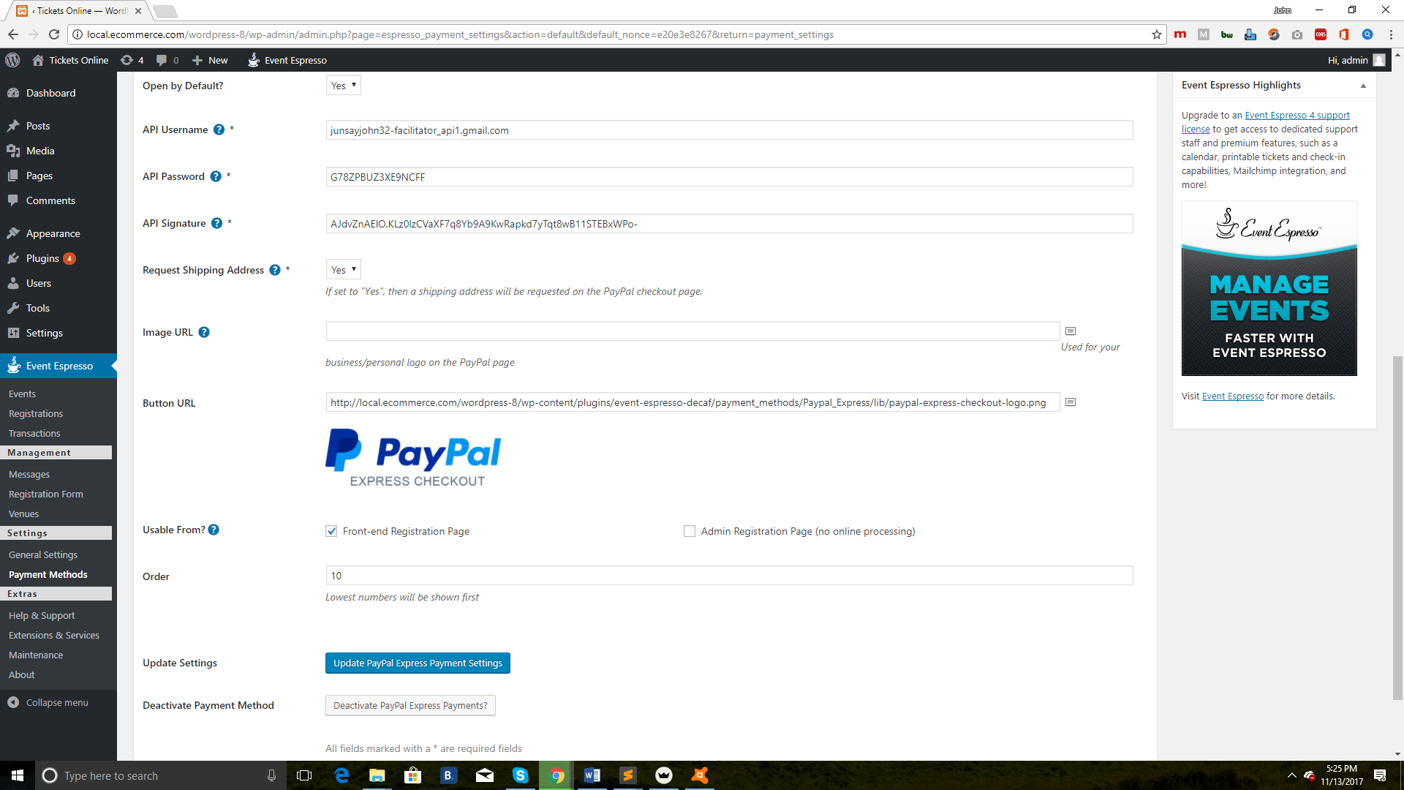

* **Payment Methods**
  + **Paypal Express Settings**: A payment gateway must first be enabled. You will then be able to configure the payment gateway. Be sure to save settings after configuring your payment gateway.
* Settings

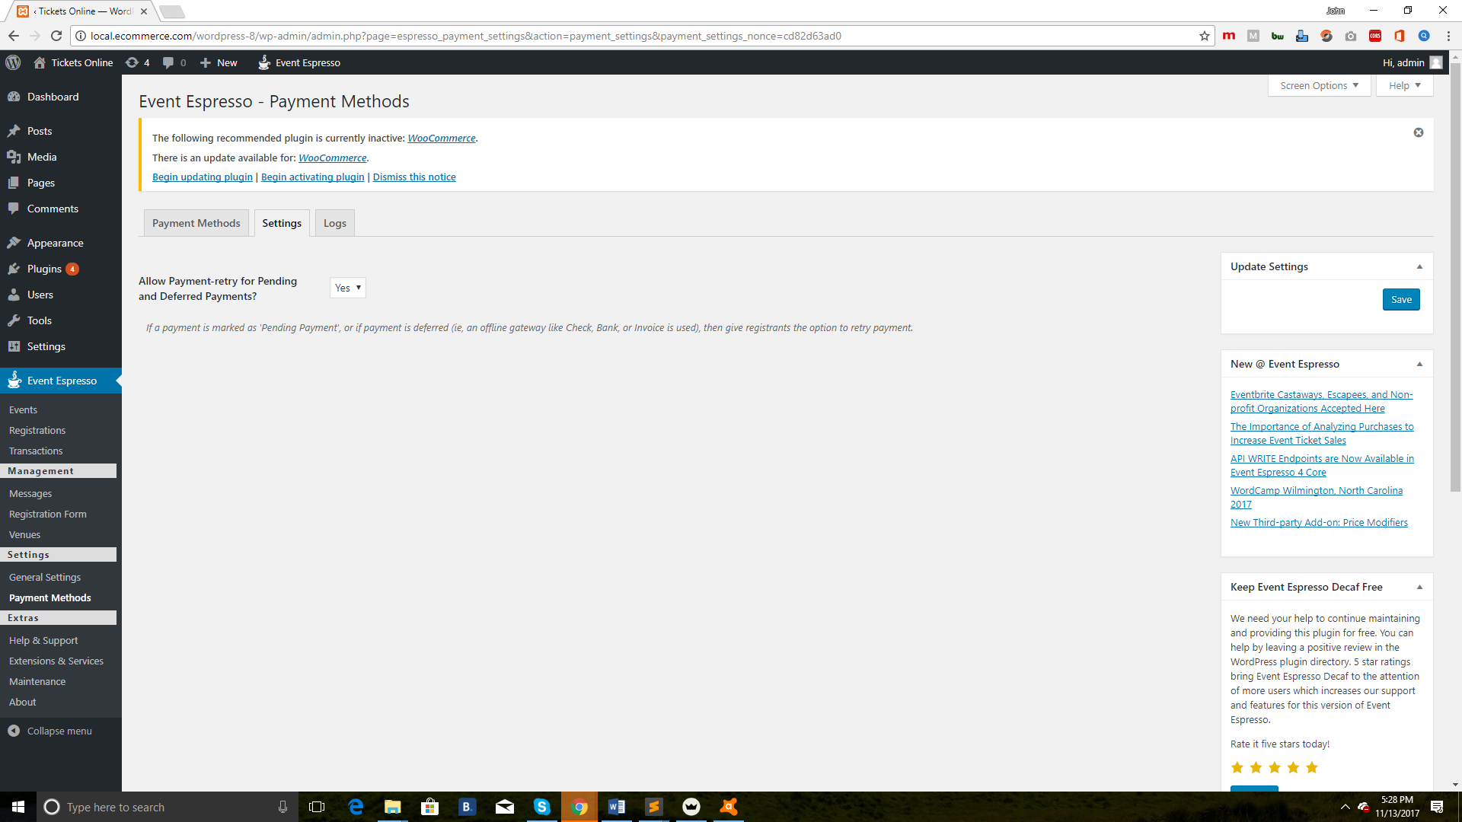

* Logs

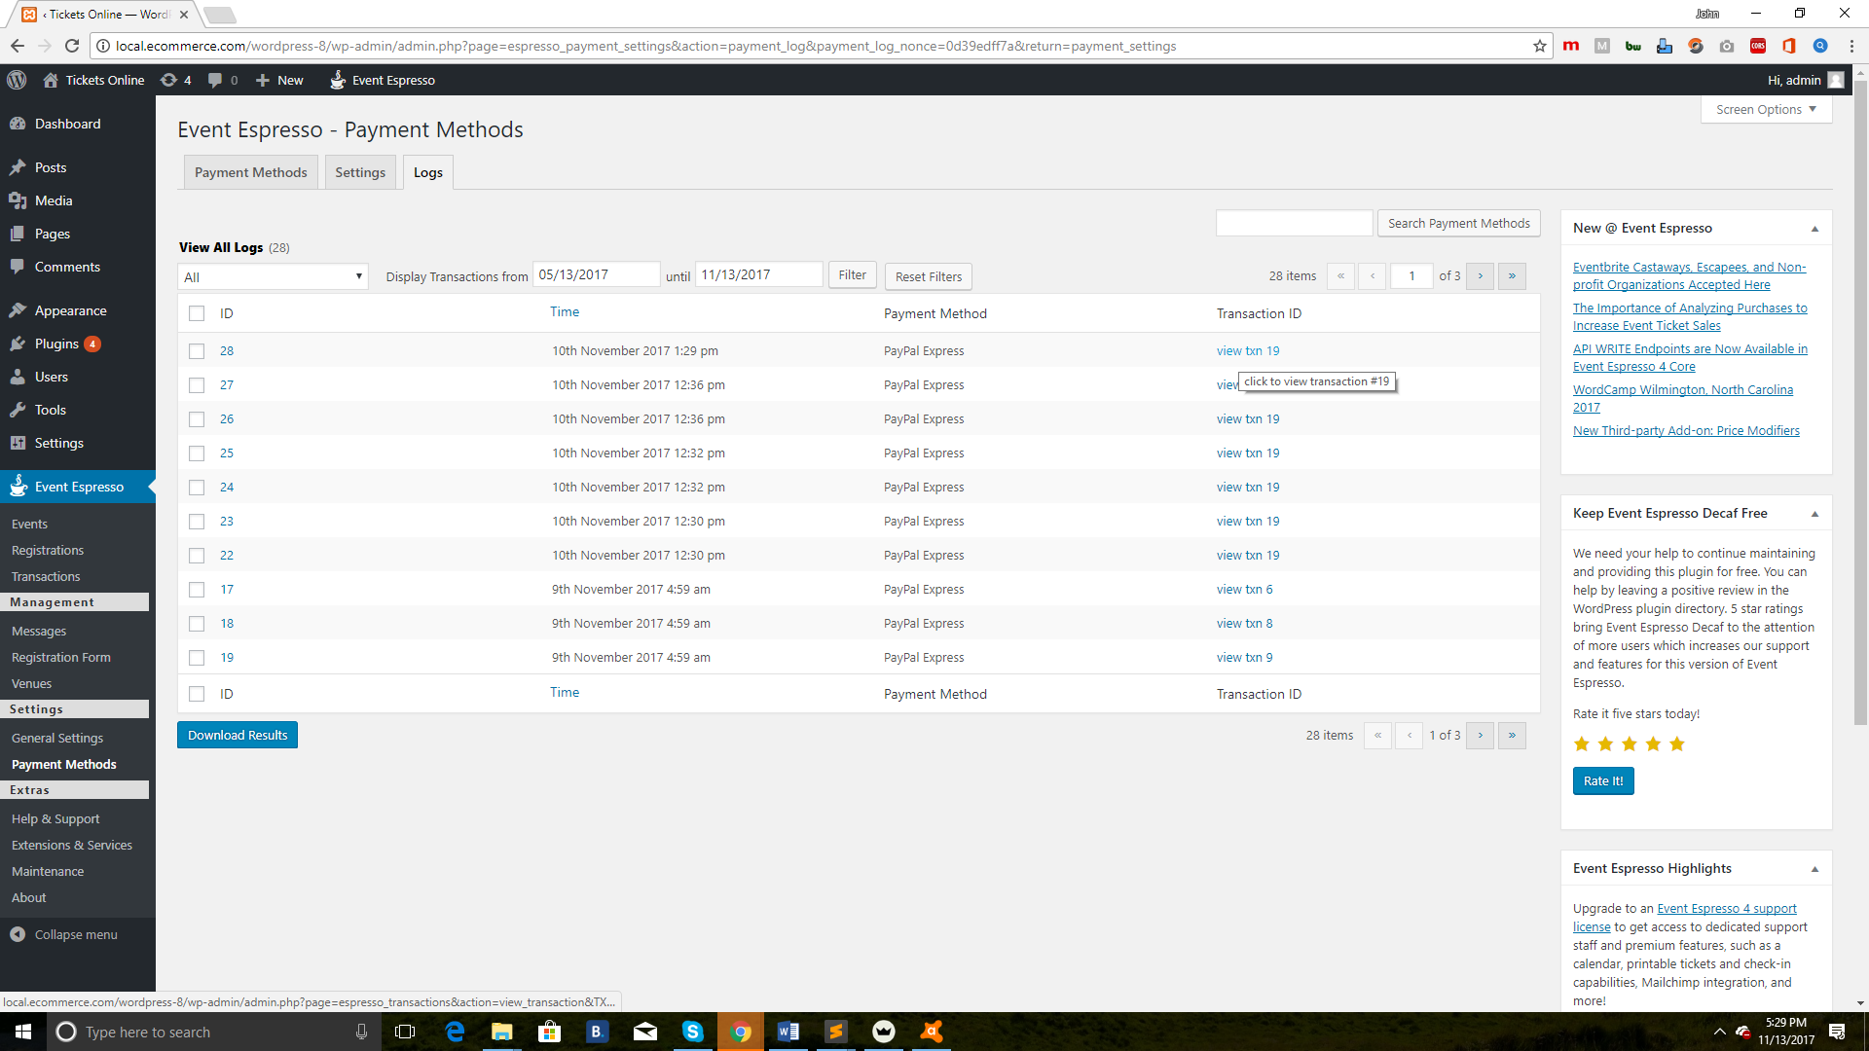

**Front****end**

